**项目式学术英语课程**

**学习内容**

**Research Traditions (II)**

**ACTIVITY**

*The two major research traditions (in social sciences) can be labeled as QUALITATIVE and QUANTITAVE. Let us look at the QUALITATIVE tradition first, which has the following characteristics:*

* Calling on inductive as well as deductive logic;
* Appreciating subjectivities;
* Accepting multiple perspectives and realities;
* Strongly arguing the value of depth over quantity;
* Collecting a lot of in-depth information about a small number of cases;
* Using in-depth interviews, focus groups, participant observation, analyzing texts, biographical research, and ethnography;
* Looking at the key issues from the viewpoint of the people involved in the study;
* Delving into social complexities in order to truly explore and understand the interactions, processes, lived experiences and belief systems that are a part of individuals, institutions, cultural groups and even the everyday;
* Recognizing the power of research over both participants and researchers;
* Not necessarily shying away from political agendas.

*Read the papers in READING 2 to see how the following statements can be better understood.*

* One advantage of qualitative research in such situations is that the research reflects the meanings which the activity has to the individual.
* Another advantage is that this research provides a more personal approach than quantitative research to the subject studied.
* A third benefit is that the results can be better understood by the average people who don’t understand statistical methods.

**READING 2**

**PAPER A**

**Teaching Assistant and Pupil Interactions: The Role of Repair and Topic Management in Scaffolding Learning**

[Paula Bosanquet](https://onlinelibrary.wiley.com/action/doSearch?ContribAuthorStored=Bosanquet%2C+Paula) & [Julie Radford](https://onlinelibrary.wiley.com/action/doSearch?ContribAuthorStored=Radford%2C+Julie)

*UCL Institute of Education*

**Abstract:**

Background: Teaching assistants (TAs) are taking increasing responsibility for the learning of pupils. A key instructional skill for TAs is the ability to scaffold learning.

Aim: To explore the interactions of TAs in relation to scaffolding as a theory of instruction.

Methods: Observational data in the form of video were collected. Conversation analysis was used to examine these interactions.

Results: Examples are explored where repair of troubles and construction of topic are highly led by the TA. As such, these interactions cannot be seen to constitute scaffolding.

Conclusions: Teaching assistants require training in scaffolding as an instructional strategy, and educational psychologists (EPs) could play a vital role in this respect.

Teaching assistants (TAs) (also known as paraprofessionals or teacher aides) are present in schools in England in large numbers. They spend extensive time with pupils at risk of losing academic ground and those with Special Educational Needs and Disabilities (SEND) (Blatchford, Russell, & Webster, [2012](https://onlinelibrary.wiley.com/doi/10.1111/bjep.12231#bjep12231-bib-0002)). TAs becoming responsible for the education of the most vulnerable pupils are being increasingly seen across the world, for example in the United States, Finland, Australia, and Ireland (Giangreco, Doyle, & Suter, [2013](https://onlinelibrary.wiley.com/doi/10.1111/bjep.12231#bjep12231-bib-0007); Webster & Blatchford, [2013](https://onlinelibrary.wiley.com/doi/10.1111/bjep.12231#bjep12231-bib-0029)). However, this is reported to have the effect of separating these pupils from the teacher and quantitative research has raised serious questions as to the overall impact of TA support on pupil progress, showing that there is a negative relationship between the numbers of hours of TA support and the progress of supported pupils in maths, English, and science (Blatchford *et al.*, [2012](https://onlinelibrary.wiley.com/doi/10.1111/bjep.12231#bjep12231-bib-0002)).

Teaching assistants are also often responsible for running intervention (‘catch‐up’) programmes. Early intervention for poor readers is essential as individual differences in reading do not diminish over time, and poor readers are less likely to engage independently with texts, further hampering their progress (Mol & Bus, [2011](https://onlinelibrary.wiley.com/doi/10.1111/bjep.12231#bjep12231-bib-0013)). These interventions should focus on supporting word recognition and comprehension skills, as well as the development of related cognitive skills (Bast & Reitsma, [1998](https://onlinelibrary.wiley.com/doi/10.1111/bjep.12231#bjep12231-bib-0001); Verhoeven & van Leeuwe, [2008](https://onlinelibrary.wiley.com/doi/10.1111/bjep.12231#bjep12231-bib-0028)).

In order to prevent the pupil becoming dependent on adult support (which is likely to contribute to negative progress), this study proposes that careful consideration is given to the type of support that TAs provide. Teacher/pupil interaction which focuses on scaffolding has been shown to lead to positive outcomes (Mercer & Littleton, [2007](https://onlinelibrary.wiley.com/doi/10.1111/bjep.12231#bjep12231-bib-0012); Van de Pol, Volman, & Beishuizen, [2010](https://onlinelibrary.wiley.com/doi/10.1111/bjep.12231#bjep12231-bib-0027)). The reciprocal teaching of reading has been shown to positively impact on pupil progress. The teacher interaction continuously adjusts to the student’s current need (providing scaffolding), and joint construction of understanding is built amongst the group. A close relationship between improvement in dialogue and performance in tests has been noted (Palincscar & Brown, [1984](https://onlinelibrary.wiley.com/doi/10.1111/bjep.12231#bjep12231-bib-0015)). The requirement of pupils to explain, elaborate on, and defend responses makes changes in conceptual understanding more likely, and there is a strong focus on procedural understanding rather than reproductive learning (Brown & Palincscar, [1989](https://onlinelibrary.wiley.com/doi/10.1111/bjep.12231#bjep12231-bib-0005)). In addition, the group situation provides greater opportunities for pupils to contribute and to be involved at a level appropriate to their understanding (Brown & Palincscar, [1989](https://onlinelibrary.wiley.com/doi/10.1111/bjep.12231#bjep12231-bib-0005)).

Scaffolding is the most suitable theory of instruction for TAs as they work mainly one‐to‐one or in small groups and the intention should be to fade the amount of support required so that the pupil becomes more independent. In addition, intervention programmes often occur in a group setting, so opportunities should be available for pupils to benefit from this social context.

Scaffolding has three key aspects (Van de Pol *et al.*, [2010](https://onlinelibrary.wiley.com/doi/10.1111/bjep.12231#bjep12231-bib-0027)):

1. Contingency: The chaining together of interactional turns, so that the pupil’s progress is constantly monitored and carefully calibrated responses are given by the adult to address difficulties and move the pupil forward.
2. Fading: ‘providing the child with the minimal help needed to ensure joint success’ (Wood & Wood, [1996](https://onlinelibrary.wiley.com/doi/10.1111/bjep.12231#bjep12231-bib-0032), p.7). In this way, the pupil develops independence in performing the task (and similar tasks), thereby reducing reliance on the expert support offered by the adult.
3. Handover: The adult’s responses act to hand over responsibility to the learner over a period of time (Wood, Bruner, & Ross, [1976](https://onlinelibrary.wiley.com/doi/10.1111/bjep.12231#bjep12231-bib-0031)).

These three areas are closely connected, with contingent teaching arguably the key aspect as it ‘appears to lead to fading that can lead, in turn, to transfer of responsibility’ (Van de Pol *et al.*, [2010](https://onlinelibrary.wiley.com/doi/10.1111/bjep.12231#bjep12231-bib-0027), p.287). The act of scaffolding has to be done in the moment and therefore relies purely on the quality of the adult/pupil interaction. TAs therefore require pedagogical skill in making moment‐by‐moment decisions based on the response of an individual or group to the task in hand.

The main interactional structure found in classrooms is the IRF (initiation–response–feedback; Sinclair & Coulthard, [1975](https://onlinelibrary.wiley.com/doi/10.1111/bjep.12231#bjep12231-bib-0025)). The ‘initiation’ is generally a question, usually with a known answer. The ‘response’ is the pupil’s best guess at the answer. The third move evaluates the pupil’s response against that expected. This structure is being extensively reinterpreted by conversation analysis (Macbeth, [2004](https://onlinelibrary.wiley.com/doi/10.1111/bjep.12231#bjep12231-bib-0011); Radford, Ireson, & Mahon, [2006](https://onlinelibrary.wiley.com/doi/10.1111/bjep.12231#bjep12231-bib-0020)). This reinterpretation has highlighted that both the initiation and feedback moves need to be designed in very specific ways for youngsters with SEND in order to ensure contingency and therefore scaffold learning. This study offers a fresh interpretation of TA/pupil discourse in literacy intervention sessions in the light of this. Specifically, it will consider repair and topic management.

First, repair is needed more often, and repair sequences may need to be extended, owing to extensive errors and differences in responses by pupils with SEND (Radford, Ireson, & Mahon, [2012](https://onlinelibrary.wiley.com/doi/10.1111/bjep.12231#bjep12231-bib-0021)). Repair occurs when there is a problem in the interaction (i.e., when a pupil fails to provide a relevant next turn). It is defined as the practices used to deal with problems in speaking, hearing, or understanding the talk in conversation (Schegloff, [2000](https://onlinelibrary.wiley.com/doi/10.1111/bjep.12231#bjep12231-bib-0023)). Effective scaffolding requires careful formulation of the feedback move. It may take several turns for the TA to draw out exactly what resources the pupil is drawing on in attempting to repair the trouble and provide appropriately matched support (Wood *et al.*, [1976](https://onlinelibrary.wiley.com/doi/10.1111/bjep.12231#bjep12231-bib-0031)). Feedback moves by the adult need to build contingently on the response (provide a repair initiator) in order to prompt self‐repair (Macbeth, [2004](https://onlinelibrary.wiley.com/doi/10.1111/bjep.12231#bjep12231-bib-0011)). Correction in the feedback position is the least preferred move as it does not require the pupil to draw on their own resources or attempt self‐repair (Radford, [2010](https://onlinelibrary.wiley.com/doi/10.1111/bjep.12231#bjep12231-bib-0016)). It therefore would not meet the fading or hand over aspects of scaffolding. If correction has to be used, the next pupil turn is crucial in monitoring their engagement with the corrected form (to demonstrate take‐up). This shows that the pupil has oriented to the learning point and handover is occurring. Therefore, features of TA talk which might be expected to aid learning would include extended sequences of step‐by‐step responses which are closely matched to the current level of understanding displayed by the pupil and which move the pupil further towards self‐correcting and the avoidance of immediate correction.

How topics are taken up and continued during the ongoing interaction is also a key area for the TA. The IRF feedback move does not necessarily extend or develop the topic unless modified to do so (Cazden, [2001](https://onlinelibrary.wiley.com/doi/10.1111/bjep.12231#bjep12231-bib-0006); Mroz, Smith, & Hardman, [2000](https://onlinelibrary.wiley.com/doi/10.1111/bjep.12231#bjep12231-bib-0014)). Modifications involve balanced adult/pupil control during initiation and feedback moves, to encourage topic extension and development by the pupil. Open topic invitations allow pupils to display their current knowledge and understanding through eliciting their ideas and opinions. Consistent with scaffolding theory, these sequences operate as ‘zones of negotiation’ when the interaction is pitched beyond the learner’s current developmental level and the adult is responding to the learner’s agenda in a contingent way (Radford *et al.*, [2006](https://onlinelibrary.wiley.com/doi/10.1111/bjep.12231#bjep12231-bib-0020)). Effective scaffolding depends on how well participants are able to co‐construct knowledge through the interaction (how skilled they are in chaining together utterances and orienting to the learning goal for that part of the task). Therefore, TA talk which might be expected to support learning would include the encouragement of pupils to explain, defend, and elaborate on their responses (Brown & Palincscar, [1989](https://onlinelibrary.wiley.com/doi/10.1111/bjep.12231#bjep12231-bib-0005)).

Recent work that analysed the talk between TAs and teaching groups during classroom maths sessions has shown that the traditional IRF pattern was used extensively by TAs (Radford, Blatchford, & Webster, [2011](https://onlinelibrary.wiley.com/doi/10.1111/bjep.12231#bjep12231-bib-0017); Rubie‐Davies, Blatchford, Webster, Koutsoubou, & Bassett, [2010](https://onlinelibrary.wiley.com/doi/10.1111/bjep.12231#bjep12231-bib-0022)). TAs focused on task completion, whereas teachers focused on learning, and TAs were reactive, whereas teachers were proactive. Specifically, it was found that TAs gave answers, whereas teachers prompted self‐checking and deeper thinking; feedback from TAs focused on task completion, whereas teachers gave clearer explanations and spent more time on this. Furthermore, the feedback move by TAs often supplied the answer or provided very high‐level support (Radford *et al.*, [2011](https://onlinelibrary.wiley.com/doi/10.1111/bjep.12231#bjep12231-bib-0017)). Teacher talk might therefore be argued to be more closely aligned with scaffolding than TA talk.

However, coding teacher/TA talk is problematic in relation to scaffolding, as both the talk of the adult and the pupil are essential in determining whether scaffolding is occurring. In addition, scaffolding is a dynamic process, where turns over a period of time may need to be considered (Van de Pol *et al.*, [2010](https://onlinelibrary.wiley.com/doi/10.1111/bjep.12231#bjep12231-bib-0027)). This qualitative research therefore extends and builds on previous research by carrying out close analysis of the interactions between TAs and pupils during literacy intervention sessions. Specifically, it looks at the details of interactions over a number of turns to see whether the learner is actively participating (a necessity for scaffolding to occur). It identifies interactive strategies used by TAs that have helpful or unhelpful implications for learning by considering whether they work as contingent in the ongoing interaction and indicate fading and handover of responsibility. This allows conclusions to be drawn as to the extent that the interactions between TAs and pupils may be considered scaffolding. We then set out the specific areas for professional development which have implications for ways in which EPs can support schools.

The research questions were as follows:

What repair practices are used by teaching assistants and pupils when troubles arise?

What practices are used by teaching assistants and pupils for the management of topic?

**Method**

The aim of this project was to explore the interactions between TAs and small groups of pupils during literacy intervention sessions. It used naturalistic observation involving the collection of video material as the primary data and supplementary information in the form of interviews and documents.

A total of 22 video recordings were made of eight teaching groups, involving four TAs from two English primary schools and one infant school. The schools were all larger than average, with two schools having significant numbers of pupils learning English as an additional language. The teaching groups were an opportunistic sample. All sessions recorded naturally occurring interactions during literacy sessions which were based on structured or scripted materials (DfES produced Early Literacy Support and Additional Literacy Support programmes, and an intervention produced by a local authority). These catch‐up programmes focused on phonics, spelling, and guided and supported reading and writing, and were led by the TA. All of the programmes were well established in the schools; TAs had received between 1 and 2 days of training in relation to the materials, provided by the local authority when the programmes had been introduced. The sessions recorded were the normal sessions timetabled to be run by the TAs on the days when recording had been organized. Interventions of this type are common in primary schools, and so these recordings are representative of normal teaching and learning activity. The researchers were not present during the recording, although the video camera was in clear sight of the participants. There was initial acknowledgement of the camera by some pupils, but, subsequently, behaviours appeared not to be influenced by the presence of the camera (Jordan & Henderson, [1995](https://onlinelibrary.wiley.com/doi/10.1111/bjep.12231#bjep12231-bib-0010)). The British Educational Research Association ethical guidelines were followed, paying special attention to issues of confidentiality, anonymity, and data storage (British Educational Research Association, [2011](https://onlinelibrary.wiley.com/doi/10.1111/bjep.12231#bjep12231-bib-0004)). Written consent for the collection, analysis, and public use of data for illustrative purposes was obtained from the head teacher, TAs, and parents.

Full details of the context of each recording and participants involved are set out in Table [1](https://onlinelibrary.wiley.com/doi/10.1111/bjep.12231#bjep12231-tbl-0001). Pupils involved in the sessions had been identified as being between 3 months and 1 year behind their peers in literacy skills, based on teacher assessment. Teachers had also completed a screening activity, provided with the programme materials, to identify pupils to be included in the groups.

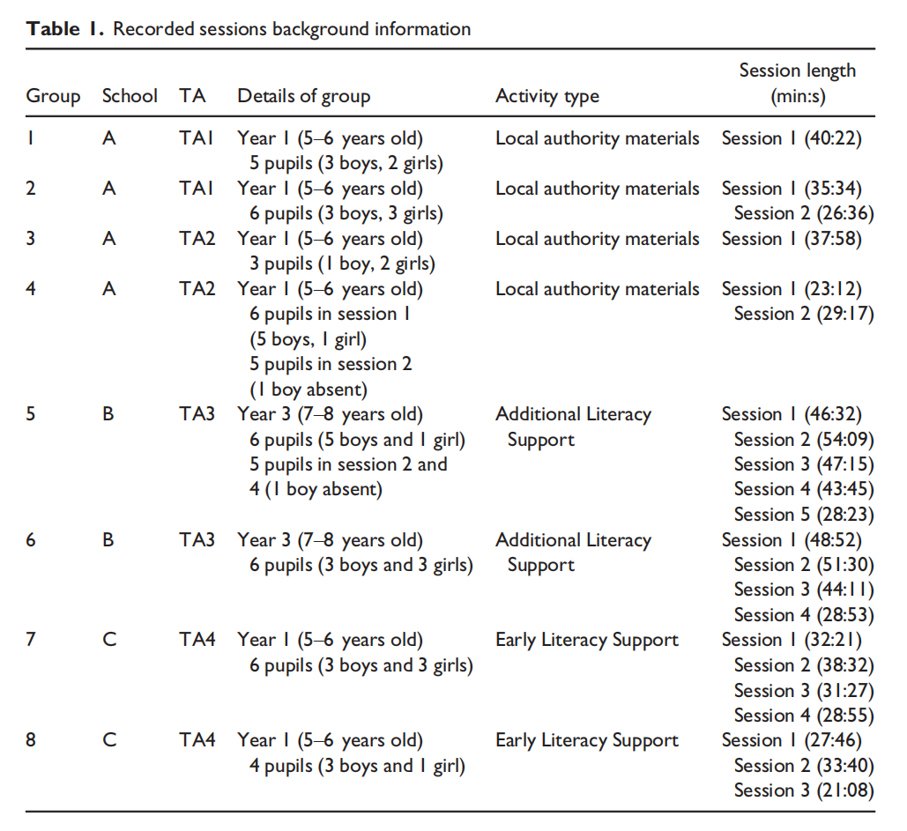

***Transcription and analytic process***

All the recorded sessions were transcribed in full. Using conversation analysis (CA) as an analytic framework, a theory building approach was taken (Ten Have, [2007](https://onlinelibrary.wiley.com/doi/10.1111/bjep.12231#bjep12231-bib-0026)).

There are two types of CA, pure and applied. Applied CA studies the way in which interactions demonstrate orientation to specific situations and requirements (Ten Have, [2007](https://onlinelibrary.wiley.com/doi/10.1111/bjep.12231#bjep12231-bib-0026)). This approach focuses on identifying ‘telling instances’ which are not claimed to be generalizable, but which show how participants are orienting in interesting ways to the process in hand. This study therefore extends more generalized findings from previous research into TA/pupil interactions (Rubie‐Davies *et al.*, [2010](https://onlinelibrary.wiley.com/doi/10.1111/bjep.12231#bjep12231-bib-0022)). It looks at the dynamic nature of the interaction across several turns to consider whether contingent teaching is occurring and whether the interactions contain evidence of fading and transfer of responsibility.

Unmotivated looking was employed to find a sequence of interest (showing repair or co‐construction of topic). When transcribed, this episode was then used as a basis for finding similar instances across the data set. Once a collection was built, one episode which was considered ‘typical’ was analysed in more detail, involving repeated viewing, and the adding of all available linguistic and paralinguistic features and gestures. Particular attention was paid to identifying the action being performed in each turn, as shown by the next‐turn proof procedure (Ten Have, [2007](https://onlinelibrary.wiley.com/doi/10.1111/bjep.12231#bjep12231-bib-0026)).

Where episodes were identified as different, these were used to build new collections. The first analysis was carried out by the first author, with the second author checking the analysis to guard against the imposition of pre‐determined theories and assumptions (Hutchby & Wooffitt, [1998](https://onlinelibrary.wiley.com/doi/10.1111/bjep.12231#bjep12231-bib-0009)). As each sequence of repair or topic generation/extension is unique, it is not possible to provide statistics in any meaningful way. The purpose is to generate theory rather than claim that all TAs make similar interactional moves.

Once these collections were in place, comparisons were made between the repair and topic strategies being exhibited and those which have been previously established by research as potentially helpful in relation to scaffolding. For repair, this was consideration of whether TA responses to difficulties led the pupil to self‐repair, and whether the group context supported repair. For topic, whether topics were co‐constructed and sustained through active pupil participation was considered. This allowed conclusions to be drawn regarding the extent to which the interactions studied were likely to provide a quality learning experience.

**Results**

Examples from the collections studied are explored, and data extracts are provided to illustrate some key points for consideration. In some cases, quantification has been provided to clarify that this was not a single instance. However, in line with CA practice, the intention was to explore and clarify key aspects of TAs’ use of interactional strategies.

***Repair sequences are not extended***

On a positive note, the data showed that scaffolding is evident during TA/pupil interaction, where the pupil is provided with an opportunity to self‐repair before a higher level of support or a correction is given. However, turns which offer a lot of support to the pupil were in evidence, such as telling the pupil the strategy to use (e.g., ‘sound the word out’, used 35 times in the data set, or ‘look at the picture’, used five times) or a substantial clue which requires little independent effort on the part of the pupil. Short repair sequences were found, where either a correction is immediately provided (193 examples) or only one repair move, such as a prompt, is used before correction (31 examples). In the following example, the TA provides a repair initiator and then, when the self‐repair fails, the correct answer is given.

The pupils are taking turns to read sentences that they have composed. The sentence being read by Sam is ‘When I came to school today I forgot my book at home’ (sic). The TA is running her pencil along the top of the words as they are read aloud.



The trouble source is the second syllable of the word ‘forgot’ which is read by Sam as ‘forget’ (line 1). A repair initiator is provided by the TA in line 2; this combines two prompts which take the form of the verbal repetition of the first syllable together with the gesture of running her pencil back to the beginning of the word. Both her verbal turn and the gesture acknowledge the correct syllable (repeat of ‘for’) and expose the source of the trouble (the second syllable). Sam fails to self‐repair because he repeats the word ‘forget’; the look towards the TA in line 5 when reading the second syllable, together with the raising intonation at the end of the word, suggests that he is aware that this continues to be a trouble and invites the participation of the TA in the repair. At this point, the TA says ‘forgot’ (line 6), stressing the /o/ and using falling intonation which indicates a correction. This correct alternative is taken up by Sam (line 7), and the task of reading the sentence continues. To summarize, a repair initiator is provided by the TA, but when the pupil fails to self‐repair, a correction is very promptly provided.

***Repair is provided through the use of non‐verbal clueing or gesture***

There were 23 examples in the data set of TAs pointing or clueing through gaze to indicate a specific word in the text. Directional language and verbal clues and hints may be used alongside the gesture. The data show that pupils rely on these gestures rather than drawing on their own resources. The following extract is an example.

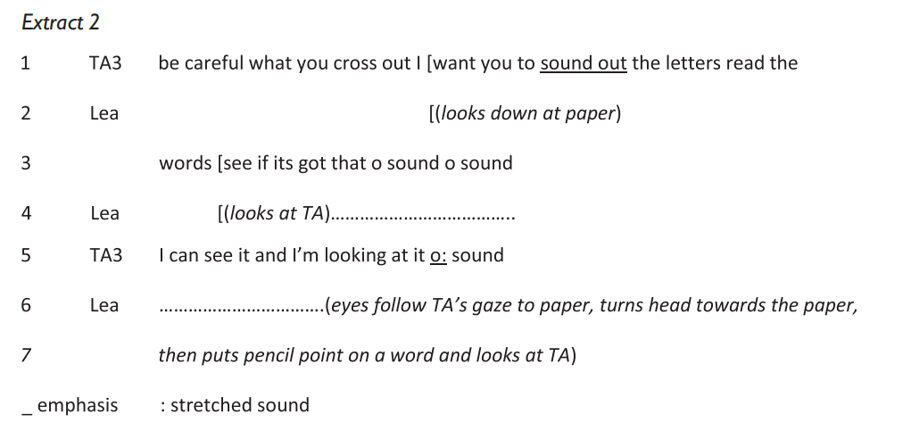

Lea looks at the TA in line 4 which the TA treats as indicating that support is required in finding the answer, thus offering two clues in response. Lea looks at the TA during her verbal hint (‘o: sound’). The second clue ‘I'm looking at it’ is more specific. Lea follows the direction of the TA’s gaze, turning her head towards the paper, and puts her pencil on a word, looking at the TA for feedback.

***Take‐up of correction is not monitored***

Analysis showed examples of the TA moving the topic on before the take‐up turn by the pupil (which would allow them to demonstrate they have oriented to the correction) is completed or sometimes started. In some cases, there is no take‐up turn. In others, a take‐up turn is attempted but overlapped or interrupted by the TA. Overlapping take‐up turns occur 15 times in the data set.

In extract [3](https://onlinelibrary.wiley.com/doi/10.1111/bjep.12231#bjep12231-fig-0003), the pupil begins a repetition of the TA’s correction, but this is overlapped by the TA when she moves the task on. The group is taking it in turns to put together graphemes in different combinations to form words. The word which has been made is *rather.*

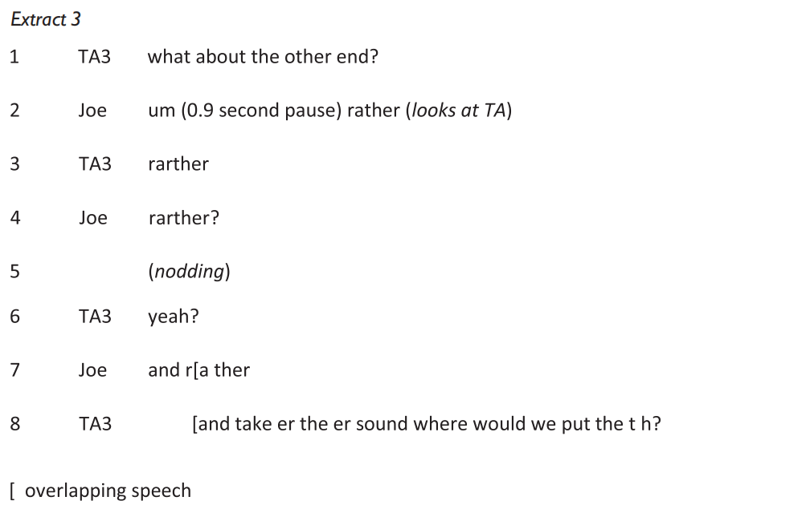

In line 2, the ‘a’ is pronounced as the short phoneme /a/, as in ‘cat’, instead of /ar/. Joe’s attempt at the word begins with ‘um’ and a 0.9‐s pause, and is followed by looking directly at the TA, suggesting that clarification is being invited. The correct alternative is provided by the TA in line 3. In line 4, the alternative is checked by Joe (‘rarther?’) who takes the ‘yeah?’ in line 6 as a prompt to repeat. However, this is overlapped by the TA (line 8) after the initial phoneme is pronounced (/r/). The use of ‘and’ in line 8 indicates that the task should move on, clarified by an instruction to put the graphemes in a new order (‘take er the er sound where would we put the t h?’). Importantly, the repeat by Joe in line 7 displays that he has failed to orient to the correct alternative (the /ar/ is still pronounced as a short /a/). However, the task has moved on and the trouble source remains unrepaired. The continued mispronunciation by Joe is likely to signify a lack of semantic understanding. A significant learning opportunity has been missed.

***Previous repair sequences are not taken up***

Given that TAs typically work with small groups during literacy sessions, the data show that pupils do not consistently orient to repair sequences involving other pupils. As a result, each trouble source has to be resolved with each pupil separately.

In extract [4](https://onlinelibrary.wiley.com/doi/10.1111/bjep.12231#bjep12231-fig-0004), the group is taking it in turns to read a word and then split it into the component elements (core word and prefix or suffix). The word being read is hostess. This word has previously been read incorrectly by another pupil (shown for context in lines 1–5) and a repair sequence completed which follows the same sequence as in extract [4](https://onlinelibrary.wiley.com/doi/10.1111/bjep.12231#bjep12231-fig-0001) (a repair initiator is provided by the TA in line 3 followed by a correction in line 5). The extract under discussion (lines 6–10) occurs 171 s later, during the same task.

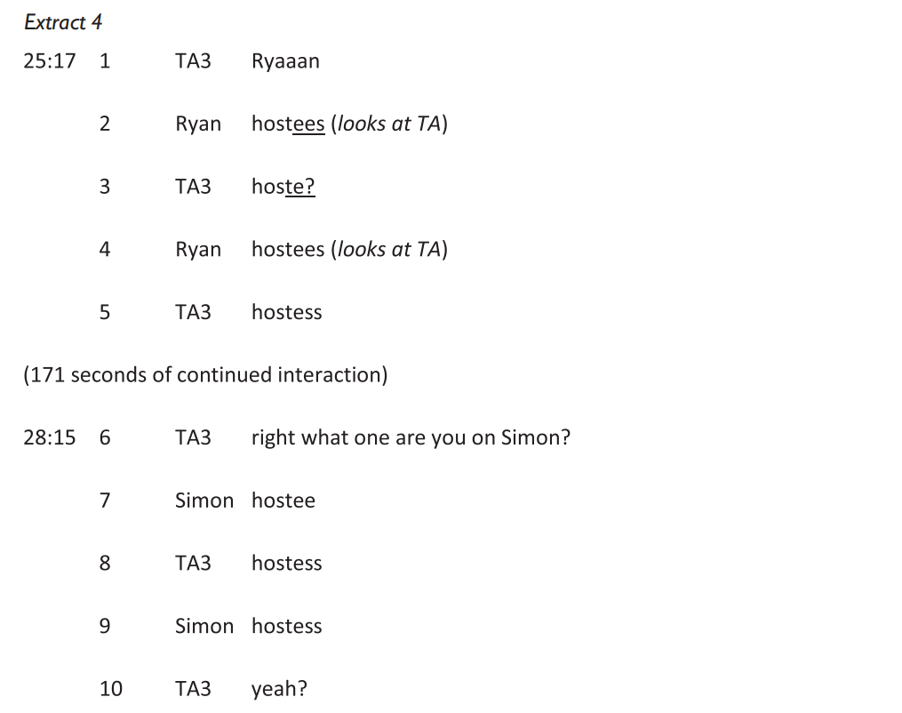

Lines 2–5 comprise a repair sequence during which the TA provides a correction specifically of the phoneme which was incorrect (/e/) and prompts Ryan to complete the word. When he fails to take up the repair, a correction is provided. 171 s later, Simon has a problem with the same word (line 7) because he reads it with a short o sound and a long /e/ sound. In the next turn, rather than providing a repair initiator, the TA provides a correction of the whole word (line 8). The fact that a problem with the same word occurs suggests that Simon has failed to orient to the previous correction. Secondly, Simon is not prompted by the TA to self‐repair. There were eight examples across the data set: where a word has previously been repaired, correction is the first response by the TA when a trouble with the same word occurs with another pupil.

***Opportunities for jointly constructed topic are closed down***

When TAs use open topic initiations (often provided by a lesson script), pupils are initially encouraged to provide a number of answers. However, the data show that a pre‐determined product is produced (in terms of both content and linguistic structure). Specific answers are selected by the TA or inserted into the interaction. Whilst topic initiating questions are treated as genuine by the pupils, the TA pursues topic in a highly structured way towards a known answer. Pupils’ responses are shaped to the extent that there are limited contributions by them.

The following extract shows an open topic invitation, which is then pursued in a way that demonstrates that the TA is working towards a specific response in terms of both content and form.

The group is writing a short story about forgetting something. They have written a sentence that says either ‘I forgot my bookbag’ or ‘I forgot my lunchbox’ (each pupil has chosen which noun to insert).



Carol treats the question ‘what do you think would happen’ as an open topic invitation. Her response is taken up and discussed by the TA. However, whilst the response could be used to form a written sentence, thus displaying an acceptance of Carol’s ideas (which would be typical of a feedback response to an open topic invitation), it is not taken up in this way. Instead, the TA rephrases the question adding ‘but if you just left your book bag at home’ (line 11). It is evident from the subsequent interaction that the effect is to restrict the possible answers. Colin’s answer ‘your mum would take it to the office’ (line 14) is responded with ‘that’s right that’s what I was thinking’, demonstrating that a ‘correct’ answer was being sought. This answer is then taken forward to the written task ‘so that would be a good sentence to write today wouldn't it’. Although there is another opportunity for the pupils to shape the sentence to be produced in line 16, topical pursuit is highly directed by the TA. She provides the beginning of the sentence ‘my mum’ and changes ‘took’ (Rob – line 17) to ‘gave my’. The only variation taken up is ‘lunchbox’ (line 20), in line with the previous sentences written by the pupils. Therefore, what appears to be an opportunity, through use of open topic invitations, for pupils to contribute original ideas is, in fact, highly directed and constrained by the TA.

**Discussion**

In relation to repair, the data show repair sequences that are not extended, so the feedback move by the TA is not working in a contingent way or demonstrating fading. Instead, after one repair initiator the TA moves on to correction. A more valuable strategy would be to provide a series of repair initiators, each building on the previous response from the pupil to move them towards self‐repair. This allows for the drawing out of the pupil’s resources and the provision of increasing levels of support as required. The use of gesture should be considered carefully as to its contingency, as it potentially provides high levels of support or correction in the same way as a verbal interactional move. The data also show that take‐up of correction is not always monitored and that repeated errors across the group are not responded to as an opportunity to pool resources towards repairing the trouble. Where correction is the only option it needs to be followed up so that it is clear that the pupil has taken up the learning point. Pupils should be encouraged to provide repair initiators for each other and to follow repair sequences between the TA and other pupils. This would support the development of reciprocal scaffolding skills (the skills of collaboratively working through a problem and drawing on peers as a source of support) (Brown & Palincscar, [1989](https://onlinelibrary.wiley.com/doi/10.1111/bjep.12231#bjep12231-bib-0005); Holton & Clarke, [2006](https://onlinelibrary.wiley.com/doi/10.1111/bjep.12231#bjep12231-bib-0008)).

Whereas working with a small group of pupils has the potential to allow for more opportunities for pursuing and extending topic between TA and pupils and between pupils themselves, these opportunities are routinely closed down and pupil turns are restricted to less complex contributions. This limits the development of higher order thinking and interaction skills, and allows fewer opportunities for the TA to draw out the knowledge and understanding of a pupil in relation to a topic. Where the topic initiation is open, it would be more appropriate for it to be followed by feedback moves which work with the pupils’ genuine responses, important for providing contingent teaching and opportunities for pupils to improve their dialogue skills (Palincscar & Brown, [1984](https://onlinelibrary.wiley.com/doi/10.1111/bjep.12231#bjep12231-bib-0015)).

When taken together, these TAs’ interactional strategies demonstrate a focus on task completion rather than developing the pupil’s learning experience, which supports the findings of previous research (Radford *et al.*, [2011](https://onlinelibrary.wiley.com/doi/10.1111/bjep.12231#bjep12231-bib-0017); Rubie‐Davies *et al.*, [2010](https://onlinelibrary.wiley.com/doi/10.1111/bjep.12231#bjep12231-bib-0022)). In these cases, TAs retain a higher level of responsibility; pupils are not involved in repair or in topic construction to the extent that the interactions might be considered skilled scaffolding. Correction is commonly used, and pupils are heavily supported through both verbal and non‐verbal interactional strategies. This demonstrates a lack of contingency. The ‘fading’ (Wood & Wood, [1996](https://onlinelibrary.wiley.com/doi/10.1111/bjep.12231#bjep12231-bib-0032)) of the responsibility for task completion is generally lacking. The strategies discussed risk encouraging dependence of pupils on adult support rather than developing their self‐repair and co‐construction of topic skills, which are essential for accessing everyday classroom tasks.

It has been persuasively argued that there needs to be a fundamental rethink of policy in relation to whether or not TAs should have any pedagogical role and that this needs to come before any changes to training and management (Giangreco *et al*., [2013](https://onlinelibrary.wiley.com/doi/10.1111/bjep.12231#bjep12231-bib-0007); Webster *et al.*, [2010](https://onlinelibrary.wiley.com/doi/10.1111/bjep.12231#bjep12231-bib-0030)). This suggests caution against the use of TAs as the default provision for pupils with SEND. A strong case has been made by research that TAs who have a classroom support role need to understand scaffolding as a concept (Radford, Bosanquet, Blatchford, & Webster, [2015](https://onlinelibrary.wiley.com/doi/10.1111/bjep.12231#bjep12231-bib-0018); Radford, Bosanquet, Webster, Blatchford, & Rubie‐Davies, [2014](https://onlinelibrary.wiley.com/doi/10.1111/bjep.12231#bjep12231-bib-0019)), which this research supports. This might be provided at a school, school cluster, or local authority level to TAs and those who manage their work. This type of training and professional development could be valuably provided by EPs when working with a school around the needs of a specific pupil or when supporting schools to develop their systems for SEND provision. Training is also needed in pre‐service teacher education and beginning teacher induction in effective interactional techniques, and ongoing continuous professional development support to help teachers effectively deploy and monitor the work of TAs.

Although there is evidence that TA led literacy interventions can have a positive impact on pupil outcomes (Sharples, Webster, & Blatchford, [2015](https://onlinelibrary.wiley.com/doi/10.1111/bjep.12231#bjep12231-bib-0024)), this research raises questions as to whether this impact could be higher if consideration is given to training TAs in working contingently when pupils are struggling; in fading support; and in using the social support of the group to enhance the learning experience. Our recommendations for training, based on evidence from this study, are that it needs to include three key areas. Correction should be used sparingly because of its implications for closing down talk and limiting pupils’ participation (Radford *et al.*, [2011](https://onlinelibrary.wiley.com/doi/10.1111/bjep.12231#bjep12231-bib-0017)). Correction might be appropriate when phonemes are incorrectly sounded (in which case, the correction should operate as a model, with the opportunity for the pupil to repeat the phoneme) or when attempting to read a proper noun which cannot be easily decoded. However, in general a strategy where the onus is on the pupil to draw on their own resources is likely to lead to a better quality learning experience. Scaffolding means that this can be done in a way which involves increasingly adult led strategies until the pupil is able to self‐repair. An initial prompt such as ‘have a think’ can be followed by a clue and then by a model if necessary, thereby developing an extended dialogue which provides the least amount of support necessary (Bosanquet, Radford, & Webster, [2016](https://onlinelibrary.wiley.com/doi/10.1111/bjep.12231#bjep12231-bib-0003)). In this way, the pupil is helped to develop self‐scaffolding strategies. Least assistance first should be encouraged as a basic principle in interactions to promote independence (Wood & Wood, [1996](https://onlinelibrary.wiley.com/doi/10.1111/bjep.12231#bjep12231-bib-0032)).

A second recommendation is to consider the role of non‐verbal clueing and gesture. Some practices, such as looking directly at the answer which the pupil is searching for, are best avoided as they are, in effect, correction. Other practices, such as the use of iconic gesture, may be used effectively as part of the scaffolding process to give a clue when required.

Finally, how topic can be jointly constructed between the TA and the learner needs to be considered at the point of task planning. During writing tasks, the key question is whether there needs to be an end product which has a fixed format and content. When there is such a need, then a pre‐prepared model might be considered rather than trying to construct the piece with the pupils (i.e., a piece of completed writing shown to the group). This model can then be unpacked, together with an explanation of why a model is being used. This is likely to make better use of time than extended interactions which change and shape pupils’ contributions to a pre‐determined format. Where a fixed format is required, this could be modelled, but the specific content left open to each pupil to allow genuine contributions.

**Conclusion**

This research adds to the growing body of evidence which demonstrates that there needs to be a fundamental change in the ways in which TAs are deployed and supported in a pedagogical role (Blatchford *et al.*, [2012](https://onlinelibrary.wiley.com/doi/10.1111/bjep.12231#bjep12231-bib-0002); Giangreco *et al.*, [2013](https://onlinelibrary.wiley.com/doi/10.1111/bjep.12231#bjep12231-bib-0007); Radford *et al.*, [2011](https://onlinelibrary.wiley.com/doi/10.1111/bjep.12231#bjep12231-bib-0017), [2015](https://onlinelibrary.wiley.com/doi/10.1111/bjep.12231#bjep12231-bib-0018)). TAs with little or no training are working with pupils with complex needs (academic, behavioural, and emotional), but the long‐term goal of each pupil working with no (or minimal) adult support must be paramount. It is only if this is seen as the overriding aim that the importance of scaffolded interaction becomes apparent. When this is clear, then the need for TAs to be trained in interactional strategies which support this becomes paramount. Research is under way to examine the changes to the interactional practices of TAs in response to such a training programme. Future research is also needed with respect to how EPs could support Special Educational Needs Co‐ordinators and other school staff in the implementation of such training.

**PAPER B**

**Reconsidering College Student Employability: A Cultural Analysis of Educator and Employer Conceptions of Workplace Skills**

Ross J. Benbow & Matthew T. Hora

*University of Wisconsin*

**Abstract:** In this research article, Ross J. Benbow and Matthew T. Hora explore the employability narrative, a view that focuses on whether colleges and universities provide students with the skills they need to be productively employed after graduation. Using sociocultural theory to problematize this narrative and qualitative methods to foreground the experiences of postsecondary educators and employers, the authors investigate conceptions of essential workplace skills in biotechnology and manufacturing fields. Their results show that though work ethic, technical knowledge, and technical ability represent core competencies valued across these communities, considerable variation exists in how members of different disciplinary and occupational subgroups value and conceptualize important skills. They found that respondents’ conceptions of skills were also strongly tied to geography and organizational culture, among other contextual factors. With these results in mind, the authors conclude that skills are best viewed as multifaceted and situated assemblages of knowledge, skill, and disposition — or cultural models — and urge the adoption of more nuanced views among educators, employers, and policy makers that take into account the cultural and contextual forces that shape student success in the workplace.

**Keywords:** Higher education; Skills; Cultural capital; Employability; Cultural models

A prevailing narrative shaping discussions about the role and purpose of postsecondary education in the early twenty-first century focuses on graduates’ “employability skills” and whether colleges and universities provide students with skills, knowledge, and abilities that will lead to productive employment. While the discourse has its roots in 1980s-era concerns about national economic competitiveness and schools’ preparation of workers for the “new” economy (e.g., Cappelli, 2015), accountability pressures in education and worries about the rising cost of college in the wake of the 2008 recession have refocused scholars’ and policy makers’ attention on graduates’ place in the labor market. Like the closely related “skills gap” argument (Hora, Benbow, & Oleson, 2016), which imagines a wide mismatch between the skills colleges and universities instill in students and the skills businesses need, the employability narrative effectively frames colleges as solely responsible for giving students skills that would satisfy employer demands, spur economic growth, and facilitate social mobility (Moreau & Leathwood, 2006). This perspective on the role of higher education, which has seen the “employability” concept effectively embedded in coursework, graduation requirements, and accountability frameworks (Clarke, 2017; Holmes, 2013; Tomlinson, 2017), has become one of the most influential narratives shaping postsecondary policy and practice around the world today.

Informing much of the discourse is a panoply of lists of valuable skills that college students should acquire in order to find success, including teamwork, problem-solving, adaptability, work ethic, and conscientiousness (e.g., Partnership for 21st Century Learning, 2018; Pellegrino & Hilton, 2012; RowanKenyon et al., 2017). Some of these skills frameworks and related policy initiatives have proven to be highly influential, such as the framework for twenty-first-century competencies (Pellegrino & Hilton, 2012) in the United States, which centered on cognitive and inter- and intrapersonal competencies; the Mayer Report in Australia, which focused on intellectual abilities, basic skills, and personal attributes (Curtis & MacKenzie, 2001); and the Dearing Report in the United Kingdom, which emphasized numeracy, communication, information technology, and learning how to learn (Dearing, 1997). Based on the need to develop a shared language so that policy makers, educators, employers, and students can avoid “misalignments” between postsecondary education and employer expectations (e.g., Business Higher Education Forum, 2010; Institute for Higher Education Policy, 2014), these skills frameworks and lists are deliberately generic and not tailored to specific disciplines, occupations, or sociocultural contexts (Clarke, 2017). There are a number of critiques of this view, however, including its reliance on all-purpose skills lists separated from occupational settings and the notion that discrete skills alone ensure student success in the labor market.

In this article we problematize the employability narrative by integrating cultural models and cultural capital theories, a framework that allows us to conceptualize skills, knowledge, and abilities as cultural artifacts internalized from one’s social (and educational) environment that can then be used to gain position, power, and prestige (Bourdieu, 1986; Lizardo, 2004; Strauss & Quinn, 1997). With this framework, we investigate how 152 educators and employers in particular disciplinary, industrial, and geographic contexts — biotechnology and manufacturing postsecondary and business organizations in the state of Wisconsin — perceived valuable workplace competencies. Using free lists, inductive thematic analysis, multidimensional scaling (MDS), and network affiliation techniques, we document respondents’ insider views about skills, their underlying structure and interconnections, and how contextual factors shaped the way skills were conceptualized.

While results confirm some aspects of extant skills frameworks associated with the employability narrative, we found that study participants did not discuss skills as uniform, distinct, unrelated competencies. Instead, they viewed skills idiosyncratically, as exhibiting differing core and peripheral structures — mapped two-dimensionally with MDS as a dense, central cluster of skills viewed similarly surrounded by an outer, sparser space of unconnected terms (Borgatti, 1998; Borgatti & Everett, 1999) — and also as being inextricably linked to one another and to specific occupational contexts and cultural communities. Based on these findings, as well as the reported prevalence of hiring processes based on assessing applicants’ “cultural fit,” we raise questions here about how useful generic skills frameworks are for explaining graduate success. With these findings in mind, we argue that postsecondary educators should resist the employability perspective that the accumulation of discrete skills alone can guarantee employment and instead adopt a more nuanced view that takes into account the cultural and contextual forces that shape student disposition, satisfaction, and success.

**The Employability Narrative and Skills Lists**

While the notion that higher education should primarily focus on workforce training has long been a part of the postsecondary landscape (e.g., Grubb & Lazerson, 2009), the construct of “employability” is a more recent development. Several trends coincided in the 1980s that led to a growing focus on college student employment after graduation: the continued massification of higher education, the growth of market-oriented governing ideologies, and the rise of a knowledge- and technology-driven economy that placed new demands on graduates and workers (Moreau & Leathwood, 2006; Tomlinson, 2012). Perhaps the most important factor driving the graduate employability narrative, however, was a steady drumbeat of employer complaints regarding the skills, knowledge, and abilities of college graduates, a deficiency, some argued, that would ultimately slow economic growth — the skills gap narrative (Cappelli, 2015). The authors of the US Department of Labor’s (1991) Secretary’s Commission on Achieving Necessary Skills (SCANS) report, for instance, ominously warned that teaching would need to change at all levels; unless it did, “neither our schools, our students, nor our businesses can prosper” (p. vii). The argument that educational systems had not caught up to workplace skills demands was echoed in the Dearing (1997) report in the United Kingdom and in the Mayer Report (Curtis & MacKenzie, 2001) in Aus-tralia, resulting in a worldwide discourse centered on student employability (Moore & Morton, 2017).

But what precisely does *employability* mean? In early discussions, the construct was often conceptualized as a binary that could be captured by a measurement of employment status: one was either employable or not (Williams, Dodd, Steele, & Randall, 2016). Later scholars argued that employability was a far more complex phenomenon representing a continuous process of personal development rather than simply whether one had a job. One widely cited definition, for example, emphasizes “a set of achievements, skills, understandings and personal attributes, that make graduates more likely to gain employment and be successful in their chosen occupations” (Yorke, 2005, p. 410). This definition best illustrates the prevailing view that employability is a multidimensional construct implicating a person’s skills, knowledge, and personality (Fugate, Kinicki, & Ashforth, 2004; Jackson, 2016).

As these concepts have developed, however, the discourse has come to be accompanied by demarcated lists, frameworks, and taxonomies of skills presumed to be valuable in the workplace. To the credit of their authors, many skills frameworks contain an implicit view that “skills” are more complex and varied than the dictionary definition of “the ability to use one’s knowledge effectively and readily in execution or performance” (Merriam-Webster, 2018). Instead, scholars have long made distinctions between different types of skills, such as soft and hard skills (Andrews & Higson, 2008) and cognitive and noncognitive skills (Farkas, 2003). A selection of skills frameworks often featured in employability discussions is included in table 1.

Along with pressure from policy makers and business interests to more closely align tertiary programming with employer needs, lists of valuable skills have played an increasingly influential role in shaping higher education policy and practice through labor-market-oriented performance schemes, in which colleges and university funding is dependent on graduate employability metrics; skills- and competency-based curricula, where skill outcomes like “learning to learn” or “self-reliance” are embedded in course and degree program requirements; and work-based learning obligations, in which graduation is conditional on internships or job placements (Hora et al., 2016; Holmes, 2013; Moore & Morton, 2017). The influence of these lists, and of the broader employability narrative, however, has opened up the discourse to considerable critique.

The first critique is that the employability discourse and attendant skills frameworks tend to focus on generic, decontextualized accounts of competence (Andrews & Higson, 2008; Clarke, 2017; Jackson, 2016). Methodologically, skills lists are typically developed by panels of experts — or from surveys with a priori lists of skills that respondents are asked to rank (Suleman, 2017) — with little open-ended input from stakeholders who have firsthand experience of education and workforce development. Skills lists, therefore, are divorced from the occupational, organizational, and sociocultural contexts in which such competencies are cultivated, assigned value, and deployed (Clarke, 2017; Jackson, 2016). This is especially problematic when one considers the unique norms and practices that differentiate disciplinary and professional groups, entry into which involves complex and time-consuming processes of enculturation (Lave & Wenger, 1991). Indeed, research in different contexts has shown that competencies cannot be adequately understood or cultivated outside specific disciplinary settings (e.g., Dannels, Palmerton, & Gaffney, 2017). In part to capture new perspectives on this issue, some scholars have begun to use interview and other field methods to allow employers, educators, and students to articulate skills needs in their own language and voice, thereby enhancing the ecological validity of resulting data (Andrews & Higson, 2008).

An associated critique is that treating skills as distinct, individualistic traits conveys an inaccurate picture of how skills, knowledge, and abilities are valued in practice and internalized via cognitive processes. In practice, both students and employers view skills as “synergetic compilations” of competencies (Andrews & Higson, 2008, p. 419), or clusters of interconnected skills that build on, relate to, and work in cooperation with one another as individuals perform various tasks. Indeed, research suggests that this notion mirrors how information is stored in the human memory as interconnected neural networks that encode particular memories, sensations, and information. As the saying goes, neurons that fire together wire together (Lowel & Singer, 1992); repeated activations of these neural networks become strong, habituated forms of thought and behavior. An important idea in cognitive psychology is that the particular environmental and sociocultural contexts in which the information or skill was originally encoded become perennially associated with it, such that certain stimuli become triggers for specific neural networks (Brown, Collins, & Duguid, 1989). When such cognitive networks are either associated with or internalized through specific communities or socially sanctioned practices, they can be considered “cultural models,” mental representations of particular knowledge, norms, or behaviors that are socially distributed (Strauss & Quinn, 1997).

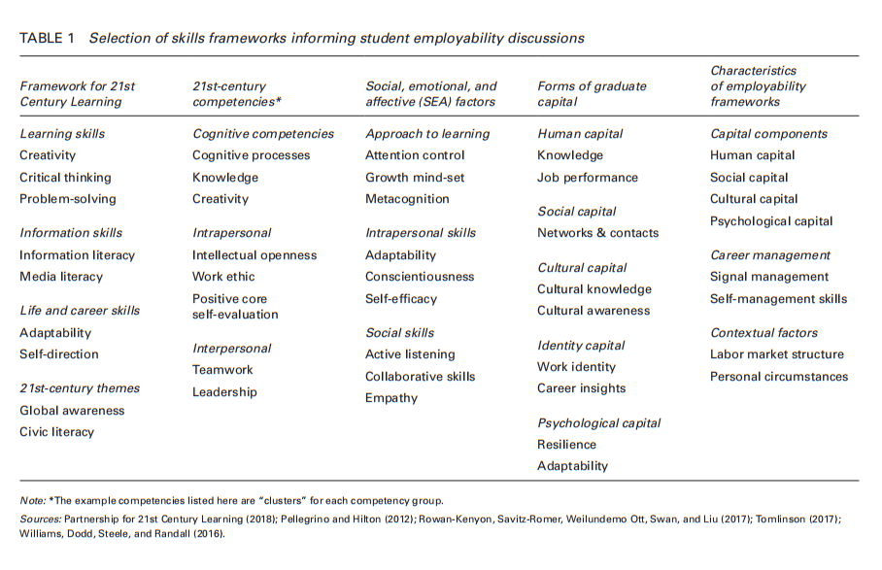

Perhaps most importantly, the employability discourse has also been critiqued for equating students’ possession of the “right” skills with employment, thereby ignoring the role business cycles, corporate hiring practices, social networks, cultural capital, and structural inequalities play in influencing access to education and job opportunities (Holmes, 2013). A singular focus on the supply side of the education-workforce equation assumes that the demand side is unproblematic, despite ample evidence regarding inequalities in higher education access, retention, and outcomes (e.g., Bastedo & Jaquette, 2011; Davies & Guppy, 1997; Jacobs, 1996; Reay, Davies, David, & Ball, 2001) and hiring discrimination along race, class, and gender lines (e.g., Bertrand & Mullainathan, 2004; Gorman, 2005; Moss & Tilly, 1996; Pager, Bonikowski, & Western, 2009; Rivera, 2012; Rivera & Tilcsik, 2016; Rooth, 2010). In response to this critique, some have linked the employability narrative not only to growing corporate-oriented perspectives in higher education but also to the dehumanizing view that people are simply ‘bundles of skills” to sell on the job market (Urciuoli, 2008). In response, alternative views of employability have incorporated elements of both the labor market and personal development (e.g., Williams et al., 2016), emphasizing that, for real people in the real world, entering a profession involves undergoing a series of intellectual and social development phases within particular economic circumstances (Fugate et al., 2004; Jackson, 2016).

**A Cultural Framework for Skill Internalization and Practice**

In light of these critiques, we draw on two distinct yet related theories, including cultural models theory from cognitive anthropology and cultural capital theory from sociology, to examine how different disciplinary and role groups define and value important workplace competencies.

First, we conceptualize skills as knowledge and abilities acquired from one’s sociocultural environment, modeled after caregivers and role models from the community, and cognitively internalized through education, a perspective that asserts a claim on both the origins and the location of “skills” within a person. A key idea in cultural models theory is that these cognitive structures are complex neural networks embedded in the situations from which they derive (Strauss & Quinn, 1997). Shouldering much of the cognitive burden inherent in our complex, day-to-day interactions (e.g., DiMaggio, 1997), these models act as encultured, shared theories of how “people, events, and objects fit together” (Ferrare & Hora, 2014, p. 793), cued by specific features of our environment and as heterogeneous as the variable social settings in which we interact. As such, cognitive activity is viewed not solely as an “in the head” phenomena but as one that is “distributed — stretched over, not divided among — mind, body, activity and culturally organized settings” (Lave, 1988, p. 1). In this way, situations, material items, and other actors are principle components of, as well as affordances and constraints on, reasoning and practice (Resnick, 1991), so much so that human action can be better understood as it is reflected in shared norms and common understandings (Lave, 1988). There are a variety of ways to study such culturally shaped competencies, such as free-listing (respondents list terms they associate with certain social or cultural categories) and pile-sorting (respondents group such terms by similarities or differences) exercises that explore the content and underlying structure of cultural domains (Borgatti, 1994). In this study we view conceptions of essential workplace skills as distinct cultural domains for particular role groups — educators and employers in manufacturing and biotechnology fields.

Second, a core idea in sociology, which we link to cultural capital theory, is that status attainment is dictated not only by credentials or academic knowledge but also by social connections, inequitable structural forces, and personal characteristics (e.g., race or class) that can act as a “signal” to employers tacitly communicating an individual’s perceived predilections and abilities (Farkas, 2003). Bourdieu (1986, p. 46), in particular, argued that the influential theory of human capital reduced these complex interactions in the social world to an ahistorical “mercantile exchange.” Instead, he focused on how the transmission of cultural capital — unequally embodied attributes and embodied competencies that are valued and rewarded within particular social settings and contexts — acts as a form of social currency in the labor market, a focus that has been embraced by some scholars of employability (e.g., Clarke, 2017; Tomlinson, 2017). Understood in a relative rather than an absolute sense (e.g., Prieur & Savage, 2011), cultural capital accrued through socialization and learning experiences allows an individual to advance in her social field, gaining competitive advantage or prestige depending on the situation and setting (Bourdieu & Passeron, 1977).

With the view that skills are internalized forms of culturally bounded competence that can be deployed as cultural capital in the labor market (Lizardo, 2004), we sought to interrogate the employability narrative by documenting the insider views of those most closely involved in the education and the employment of postsecondary graduates: higher educators and employers. In specific reference to these subgroups, we answer three research questions: (1) What skills are valued and how are they conceptualized by educators and employers? (2) How are these valued skills structured among educators and employers? (3) What contextual factors, if any, impact how educators and employers conceptualize, structure, and use valued skills?

**Methods**

The qualitative case study (Yin, 2013) we report on focused on conceptions of valuable workplace skills among two role groups (educators and employers) within two disciplinary and industrial sectors (advanced manufacturing and biotechnology) in the state of Wisconsin. We selected these fields because they encompass science, technology, engineering, and mathematics (STEM) occupations that analysts consider to be important drivers of the US economy (Carnevale, Smith, & Melton, 2011) and also because they represent a traditional cornerstone of Wisconsin’s economy (manufacturing) as well as a rapidly growing industry (biotechnology). Seeking to describe insider perspectives, we regarded respondent views as comprising unique domains of cultural knowledge for a group, the distinctiveness, content, and structure of which was an open, empirical question.

*Sampling and Data Collection*

Using Wisconsin’s Economic Development regional guidelines (Forward Wisconsin, 2016), we began by focusing on hub cities within six demarcated state regions with high concentrations of firms in the two sectors as well as on associate- and bachelor-level college and university programs channeling students into these sectors. For manufacturing, the latter included educational programs in the applied sciences, electronic systems, mechanical and industrial engineering, and industrial automation; for biotechnology, we included programs in biochemistry, biology, microbiology, and biotechnology. Wisconsin hub cities and regions included Madison in the southern region; Wausau in the central region; Green Bay in the eastern region; Milwaukee in the southeastern region; Superior in the northern region; and La Crosse in the western region.

Using a nonrandom purposive sampling technique, we created sampling frames for employers and educators in and around each of the six hub cities from state and industry-specific lists of firms and from higher education institution web pages. We then contacted these educators and employers via telephone and e-mail to request their participation. Ultimately, 75 employers representing 52 companies and 77 educators representing 17 postsecondary education institutions participated in the study. Of the companies, 43 were manufacturing firms and 9 were biotechnology firms. Of the postsecondary institutions, 8 were associate-level institutions and 9 were bachelor-level institutions. Tenure-track faculty, contingent faculty, and associate deans participated as educators; human resource coordinators, chief executive officers, supervisors, and workplace trainers participated as employers (table 2).

A team of three researchers conducted interviews between late 2013 and early 2015 using a semistructured protocol that included a free list exercise and several open-ended questions. Free list exercises elicit words, terms, or phrases that individuals and groups use to refer to a specific conceptual sphere or cultural domain (Borgatti, 1998). For our free list, we asked respondents to verbally provide, in single words or short phrases, the skills that immediately came to mind that they thought were necessary for people to succeed in their sector’s workplace. Following this exercise, we asked respondents questions that focused on views and conceptions of workplace skills they found to be valuable teaching and training practices, and hiring procedures. Interviews lasted approximately forty-five minutes and were recorded and transcribed for analysis.

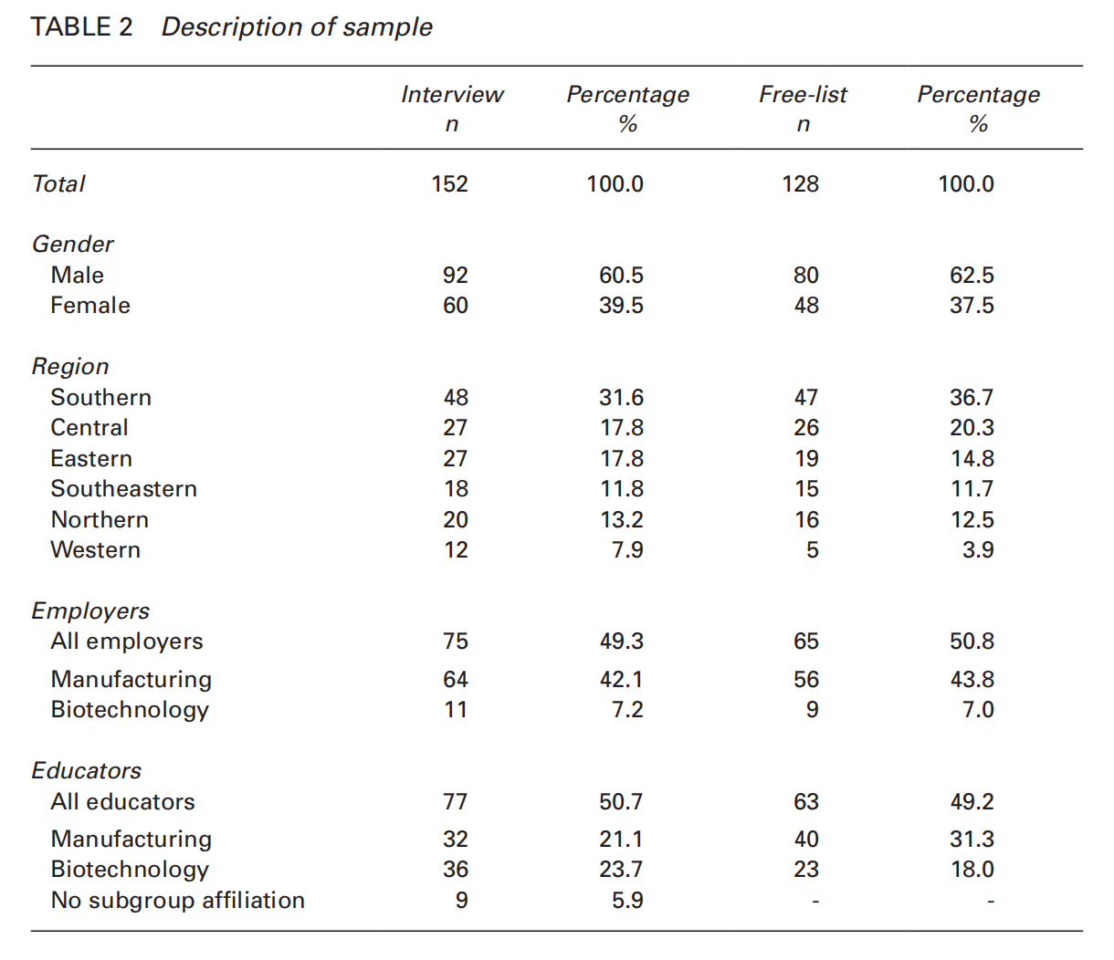

*Data Analysis*

Our analyses began with a review of the raw free list data, which revealed that twenty-four respondents had not provided information in a usable form because they did not understand the free list question, refused to be recorded, or believed their occupation or organizational role did not allow them to comment on valued skills. This resulted in a final count of 128 free lists for analysis. Then, because respondents listed “native” terms that were closely related but phrased differently (e.g., “work ethic,” “hard worker,” “dependable worker”), two analysts reviewed the raw data independently to develop lists of standardized terms and then met several times to discuss these terms before collaboratively developing a final list of ninety-four standardized terms (Quinlan, 2005). Using Anthropac (Borgatti, 1996), a software program designed to collect and analyze cultural domain-oriented information, we then analyzed data to derive term salience, a measure used in cognitive anthropology that reflects the average order and percentile rank of a term across all respondent lists (Smith & Borgatti, 1997). Salience is computed as



where *rj* = position of item *j* in the list and *n* = number of items per list. To identify the overall saliency index, the average *sj* across respondents is calculated. We conducted the free list analysis for role subgroups within disciplines (e.g., manufacturing educators and employers), the results of which are presented through saliency scores for each role and disciplinary subgroup. We also present unstandardized terms uttered by respondents for three focal salient skill terms, as well as subgroup bar graphs in which the *y*-axis includes terms ordered by salience for the entire study sample and the *x*-axis depicts saliency scores (Borgatti, 1998). These analyses are presented below in answer to Question 1.

We analyzed responses to the interview questions using an inductive coding approach. Through multiple group readings of several transcripts, we began by developing codes through a priori research interests (e.g., valued skills) and emergent themes from the data (Charmaz, 2014). After discussing and testing multiple versions of the preliminary code list, three analysts simultaneously applied twenty-seven codes across nine thematic categories (Saldaña, 2013).

Next, we began second cycle coding focused on text coded as “valued skill sets” and “contextual factors” that we analyzed using a combination of a priori codes (e.g., the most salient skills) and inductively derived codes. During this phase, we assigned respondent statements to each code and compared successive instances of an idea to previous instances to confirm or alter emerging code definitions. After separately coding 10 percent of the data, analysts met to discuss differences and then collaboratively arrived at a final code list that one analyst used to code the remainder of the text fragments. These analyses are presented below in answers to Questions 1 and 3.

We also developed a participant-by-skill code matrix in which each cell indicates whether participant *i* spoke to skill *j* or not in her free list, converting this to an item-by-item matrix of co-occurrences in which different skills more often mentioned by the same participants accrued higher similarity scores (Borgatti, 1998). We used this proximity matrix to create MDS graphs in UCINET for each subgroup (Borgatti, Everett, & Freeman, 2002). MDS graphs (Borg & Groenen, 2005) represent correlations among objects (here skills) as distances in a two-dimensional space. In nonmetric MDS, the graph displays the best possible configuration of the objects, although distances between objects are not linearly scaled but instead based on rank order. Here, the closer skill terms are to one another in a graph, the more often they were mentioned together by the participants in each subgroup. With reference to free list salience scores for each subgroup, we also circle “core” skills (commonly shared within the domain) and “peripheral” skills (more idiosyncratic) exhibited for each subgroup on these MDS graphs (Borgatti, 1998). Core skills for each subgroup are identified as terms with salience scores of .200 or above, an arbitrary cutoff point meant to encompass frequently mentioned skills in each subgroup for comparative purposes.

Finally, during the coding process we unexpectedly discovered a number of respondent reports regarding skill structure that we refer to as *skill-to-skill connections* and coded explicit references to these statements. Here, we marked instances of specific skills being connected, counted the number of respondents by subgroup making references to connections between particular skills (teamwork and communication), and then developed a skill-to-skill similarity matrix in which each cell represents the proportion of subgroup members who reported instances of specific skills connecting to one another. We used NetDraw (Borgatti, 2002) to create network affiliation graphs from these similarity matrices for each educator and employer subgroup. Each graph shows skills linked by lines of varying thickness that represent the proportion of respondents who referred to the particular skills being connected (DeJordy, Borgatti, Roussin, & Halgin, 2007). Thicker lines represent terms that were connected to one another more often. Along with MDS graphs, this analysis is presented below in answer to Question 2.

*Study Limitations*

Several limitations should be taken into account when considering our results. First, the small and self-selected nature of the sample precludes a generalization of the results to larger populations of employers and educators. Second, the employer sample is weighted heavily toward manufacturing representatives, as the biotechnology industry is proportionally much smaller in Wisconsin. Third, the interview protocol directed respondents to consider entry-level positions while answering the questions but did not indicate the specific experience or education required for these positions. While the occupations commonly referenced by participants included those requiring some postsecondary training but not a bachelor’s degree, respondents could have answered the interview questions thinking of differing positions with differing educational requirements. Finally, it is important to point out that these data do not include the views of students and employees, those whose futures depend on the issues addressed in this article. While our focus is warranted given the difficulty in accessing employee populations and the rich insider knowledge (and power) educators and employers have regarding graduates’ skills and successes, future research efforts would benefit from perspectives that allow scholars and practitioners to better understand students and employees as agents rather than subjects.

**Results and Analysis**

*Question 1: What skills are valued and how are they conceptualized by educators and employers?*

First, we report findings which demonstrate that study respondents valued and conceptualized essential workplace competencies in unique ways depending on their role and disciplinary affiliation. We report data from the free list exercise for the 128 respondents who provided usable terms using the saliency scores — a measure representing the content of each group’s cultural domains for essential workplace competencies (Borgatti, 1994; Quinlan, 2005) — for the top fourteen standardized terms in each subgroup (table 3).

These data indicate that members of each subgroup considered a delimited group of competencies as especially essential for the workplace, though each subgroup also varied in the composition and ordering of skills in their collective free lists. The manufacturing employers viewed three skills as highly salient, with scores of higher than .200 (work ethic, technical ability, and technical knowledge), while biotechnology employers had five mostly different skills in their high salience group (experience, lifelong learning, technical ability, problem-solving, and communication). Similar variability is evident in the two educator subgroups.

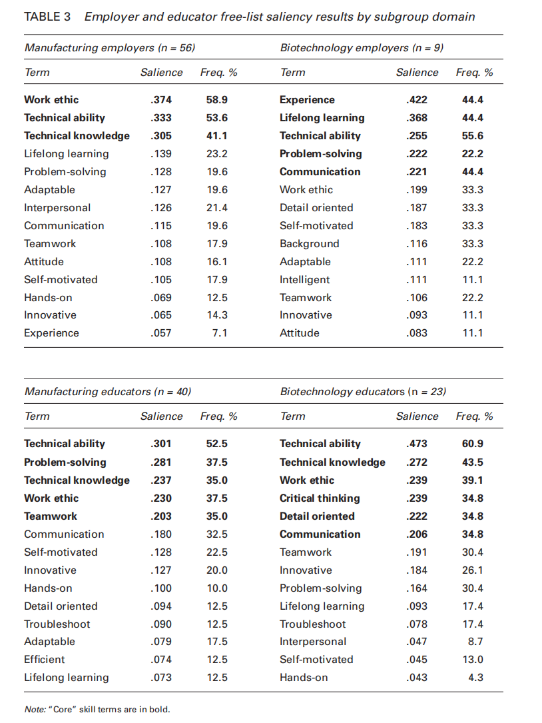

The variability between and among subgroups is also evident using bargraphing techniques. Here, for ease of comparison, we order the fourteen most salient skills across the entire sample on the y-axis (from lowest saliency at the bottom to highest at the top) with term saliency scores for each subgroup on the x-axis (figure 1).

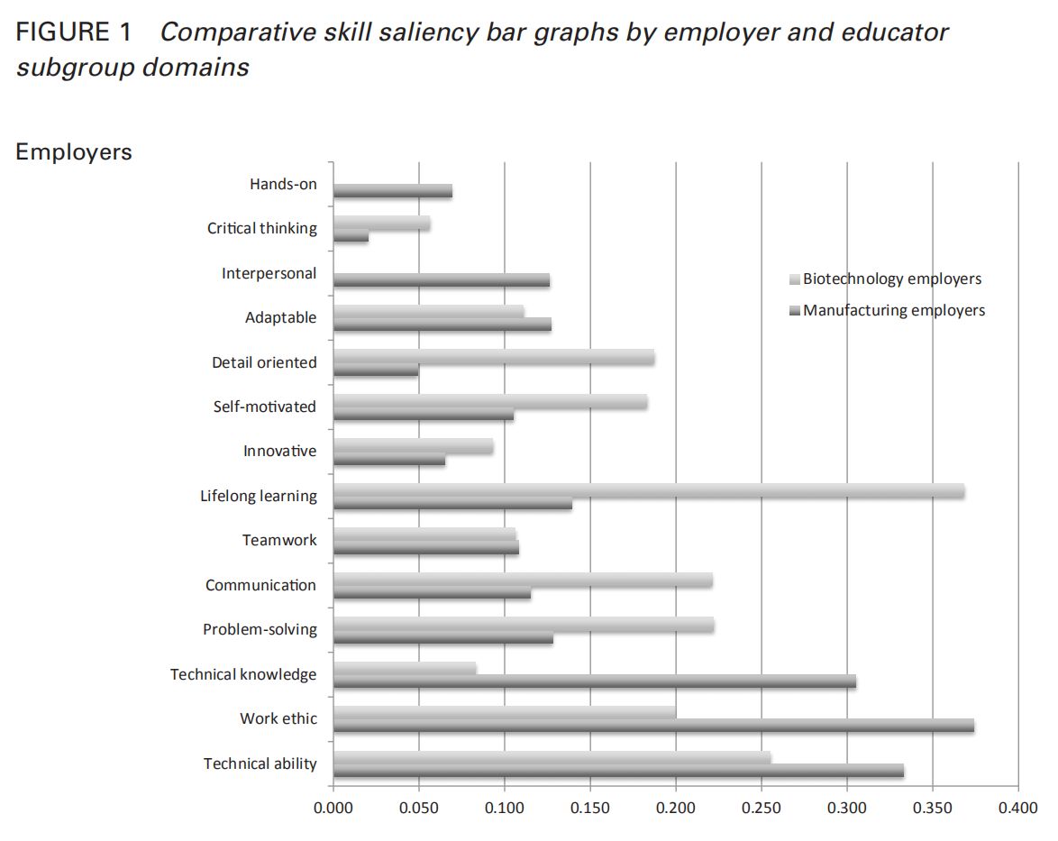

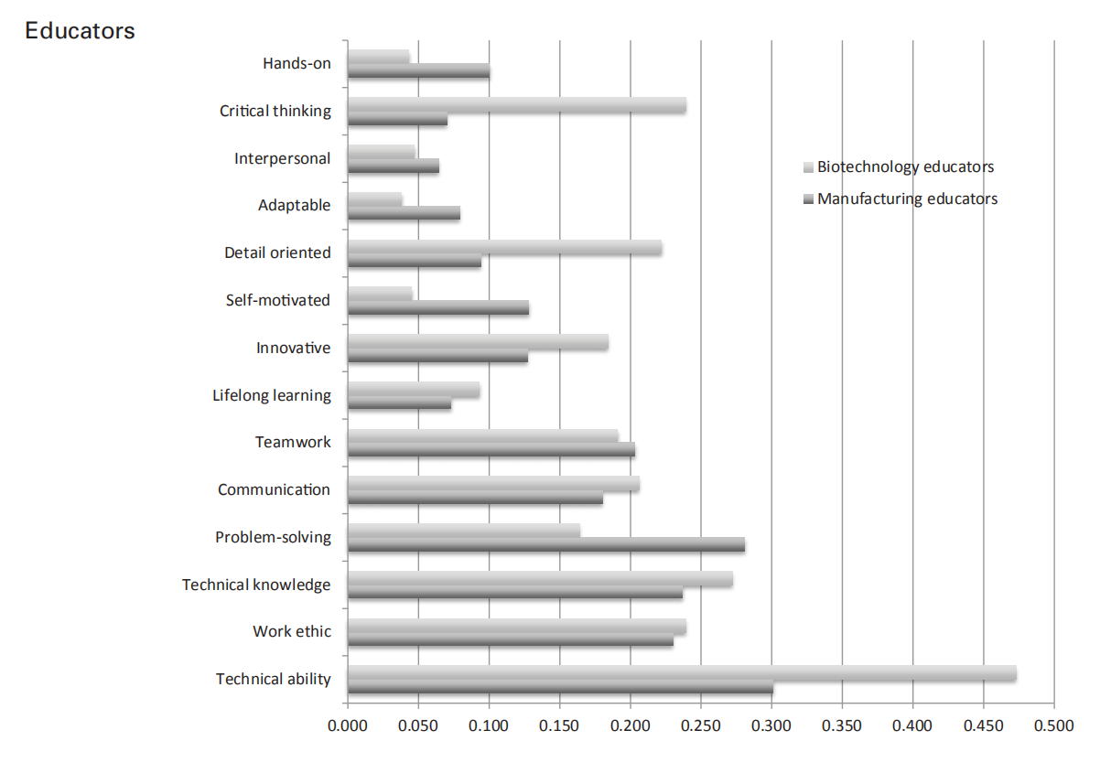

Variation is evidenced by different bar spans where skills considered to be of low salience by one subgroup sample were considered highly salient by the other subgroup. Here, for instance, we can see that “lifelong learning” was considered a much more salient term among biotechnology employers (.368) than among manufacturing employers (.139).

To explore how respondents conceptualized essential workplace skills, we examine in greater depth three of the competencies that were highly salient across the sample: work ethic, technical ability, and problem-solving. We first report some of the native terms provided in the free list exercise, then follow with important themes from the interview data.

— Work Ethic

Work ethic plays an important role in how respondents across sectors think about and define success in workplace fields. While the term was reported verbatim by twenty respondents, a number of other linked terms were subsumed under work ethic for the purposes of the free list analysis. For manufacturing employers, the most frequently mentioned terms included “prompt,” “attendance,” “quality considerations,” “dedicated,” and “hard work.” Biotechnology employers discussed work ethic with less frequency, using the terms “prompt,” “responsible,” “reliable,” and “integrity.” Manufacturing educators reported terms including “getting your hands dirty,” “prompt, “productive,” and “performing quality work,” and biotechnology educators mentioned terms such as “punctual,” “integrity,” “quality work,” and “being reliable.”

Significantly, many employers and educators in both sectors described work ethic more as an ingrained character trait than a malleable, learned competency, a finding that ties closely to conceptions of the moral value of work in the Protestant tradition (Furnham, 1984). In particular, many respondents tied work ethic to an employee’s background and upbringing. “The difference between [a good and great employee] is work ethic, hands down,” said one biotechnology employer. “They can be as brilliant as a person can be, but the one employee will do the job that they’re assigned and then that’s it, [and] the next one will do that same job and ask for more.” Among manufacturing employers, a background in farming was often considered a sign of a good work ethic. As one manufacturing supervisor said, “If they grew up on [a] farm, generally they’re hard workers, they work from dawn to dusk.” The respondent’s colleague agreed, referring to the work ethic acquired from a rural upbringing as “internal values.” The imagery of working with one’s hands was a notable theme in respondent descriptions of the character of work ethic, especially among manufacturing employers and educators, as was the subtle class-based contrast between physical labor in the blue-collar work world and tidier, more intellectual white-collar forms of employment.

— Technical Ability

Widely discussed in terms of the ability to perform procedures or tasks that were specific to particular occupations, disciplines, or workplaces, “technical ability” was only directly referenced by one respondent, with most respondents discussing more specific technical subjects or areas. For manufacturing employers, the most frequently reported term that was subsumed under technical ability was “mechanical aptitude,” followed by “computer skills,” and “technical skills.” Specific technical skills discussed by manufacturers included “machining CNC” (the ability to run computer numerical control equipment) and “reading blueprints.” For biotechnology employers, terms reported for technical ability included the tolerance for “repetitive” bench work, “lab skills,” and keeping a “good notebook.” For manufacturing educators, important technical abilities included “mechanical aptitude,” “technical skills,” “computer skills,” and “data analysis,” while biotechnology educators valued “computer skills,” “data analysis,” and “laboratory technique.”

One theme related to technical ability was how respondents described it as much as an identity or a state of mind as a set of specific manual capacities. This state of mind, some suggested, allowed individuals to either understand (and enjoy) technical work or not. Several manufacturing employers said that an individual’s particular sociocultural background and interests outside of work indicated whether or not they had technical ability. According to one manufacturing employer, “The guy who’s a welder, in one sense, may go home and work on his truck at night ... just as a piece of who they are.” Echoing the view that an agricultural background was indicative of a strong work ethic, several respondents suggested that individuals who had worked on farms or were interested in cars — usually men with a mechanical “style of life” (Bidwell, 1989, pp. 129, 130) — were perceived as being most encultured into a milieu of technical ability.

— Problem-Solving

“Problem-solving” was mentioned verbatim by twenty-seven respondents, indicating its value across group cultural domains. For manufacturing employers, other similar terms referenced included “analytic thinking,” “thinking on one’s feet,” and “investigation,” and biotechnology employers used phrases such as “analytic” and “strategic thinking.” Manufacturing educators discussed “thinking on one’s feet,” “asking the right questions,” and “mechanical thinking,” and one biotechnology educator talked about “clear thinking on the job.”

The most pervasive theme regarding problem-solving centered on the notion of adequately framing a problem in ways that made it possible to detect its root causes and devise solutions. A manufacturing employer spoke of this ability in terms of situational recognition and of perceiving “the unobvious,” whether in a broken machine or a dysfunctional system. Other respondents emphasized that this type of problem-solving was not about applying calculations or predetermined “fixes” to a situation. Instead, it entailed “thinking outside of the box” to determine the types of information required to find solutions and ultimately solve the problem. In this way, our respondents’ discussions of this skill are consistent with prior research on the nature of problem-solving in the engineering workplace (Jonassen, Strobel, & Lee, 2006). Ill-defined problems require the ability to accurately diagnose conditions and select optimal solutions.

*Question 2: How are valued skills structured among educators and employers?*

To examine the structure of skill terms within subgroup cultural domains (Borgatti, 1994; Quinlan, 2005), we created MDS graphs from free list data that help depict structural similarities and differences between reference terms. “Core” skills, or those that are more often mentioned and more similar to one another, are clustered toward the center of the graphs, while terms that are considered less similar among members of the subgroup are arranged around the periphery (Borgatti, 1998).

After viewing these MDS analyses and revisiting free list saliency results (table 3) and bar graphs (figure 1), we identified “core” workplace skills for each subgroup, defined here as terms with salience scores of .200 or above (table 3). Core workplace skills, circled in each subgroup MDS graph, are displayed in figure 2.

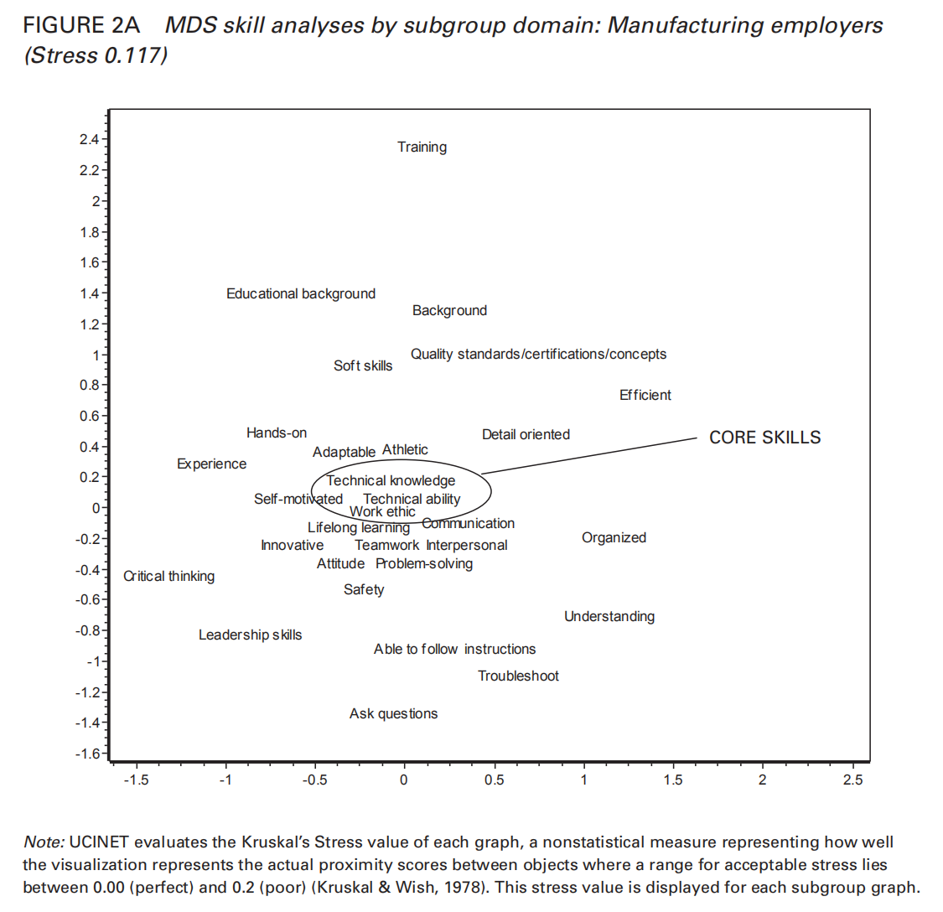

Much as distinct social groups collectively perceive certain foods (Libertino, Ferraris, Osornio, & Hough, 2012) or plants (Quinlan, 2005) as more salient in the cultural domain than do other groups, these data suggest that certain sets of workplace competencies are seen as particularly critical among some subgroups. We consider these core assemblages to be cultural models, defined as socially distributed neural networks storing knowledge, skill, and ability. The relative placement of skill terms illustrates these cultural models in different ways among the subgroups. Mirroring free list results, for instance, we can see that technical knowledge is centrally located and tightly connected to other important skill terms among manufacturing employers, even though it lies on the far periphery of the biotechnology employer graph, signifying its low association with other terms among members of this subgroup. Training, on the other hand, is the most distantly located — and therefore most loosely connected — skill term in both employer graphs. While detail oriented is positioned on the outskirts of the skills graph for manufacturing educators, it is one of several closely bound core skill terms for biotechnology educators, suggesting it is both more important and more connected to other workplace competencies for biotechnology educators than manufacturing educators. The comparative density of all skill terms within each graph, though partly a function of sample size, also indicates differing levels of connectivity between members of each subgroup, with manufacturing educators displaying a much more cohesive (or commonly perceived) skill domain than biotechnology educators, to use one example. Given the variation in how different role and disciplinary groups conceptualize and prioritize specific competencies, these data illustrate the inherent limitations of workplace skills lists that treat skills as discrete and individualized units similarly valued across cultural domains.

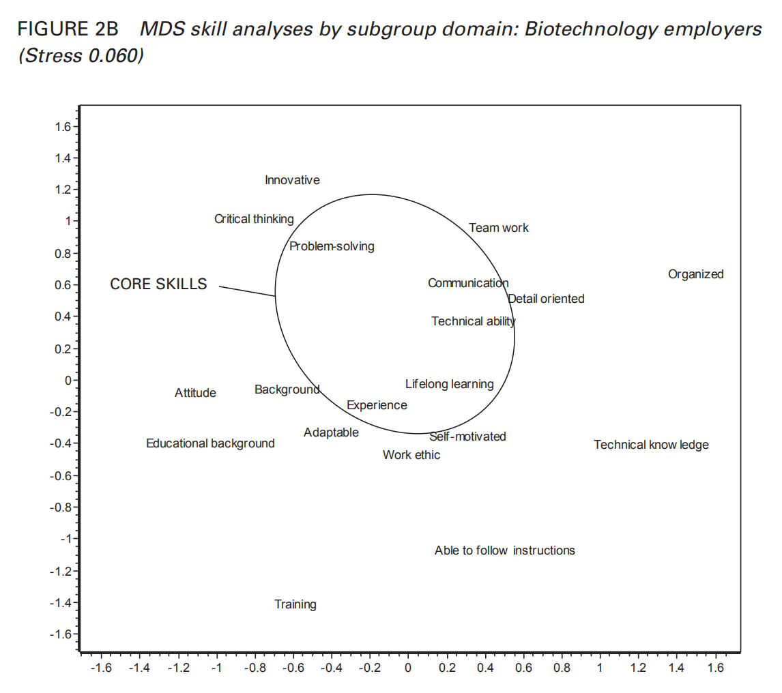

Core and periphery configurations were not the only structural qualities of valuable skills. Based on our discovery during data collection that respondents often spoke of skills as interconnected, we also analyzed interview text to examine the degree to which respondents referenced connections between and among specific skills. Ultimately, forty-three educators and thirty-seven employers explicitly mentioned connections between competencies. Using these tallies of explicit skill-to-skill connections, we create network affiliation graphs to visually represent how members of the four subgroups connected or did not connect valued skills to one another (DeJordy et al., 2007). In figure 3, each node represents a skill term, and lines between nodes represent explicit statements by participants connecting skill terms to one another. Thicker lines represent connections made by greater proportions of participants in each subgroup.

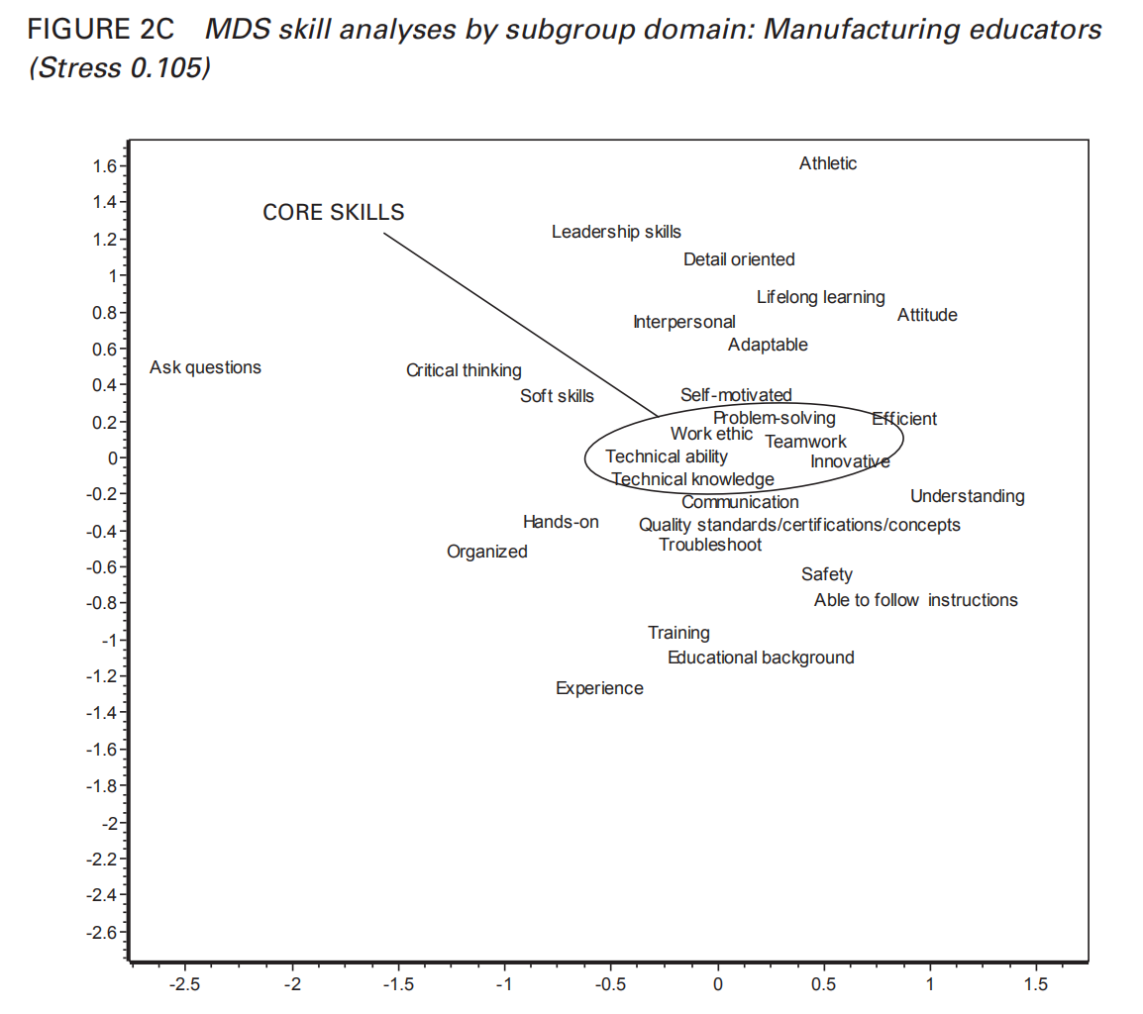

These data indicate that participants often described valuable competencies as inextricably bound, in some cases so strongly that it made little sense to discuss one skill without the other. Affiliation graphs display these interconnections among groups in various ways. The manufacturing employer network, for instance, shows an array of ties centered around teamwork, adaptable, and attitude, among other skill terms, while the biotechnology educator network shows a strong set of connections between innovation, critical thinking, and problem-solving, as well as an isolated dyad linking detail oriented and technical ability. Among biotechnology employers, lifelong learning retains strong bonds with both technical knowledge and adaptable, and experience, otherwise unconnected to other skills, is strongly tied to technical ability. The manufacturing educator network shows problem-solving retaining a wide array of different skill-to-skill connections, with a concentrated triad between it, technical knowledge, and technical ability.

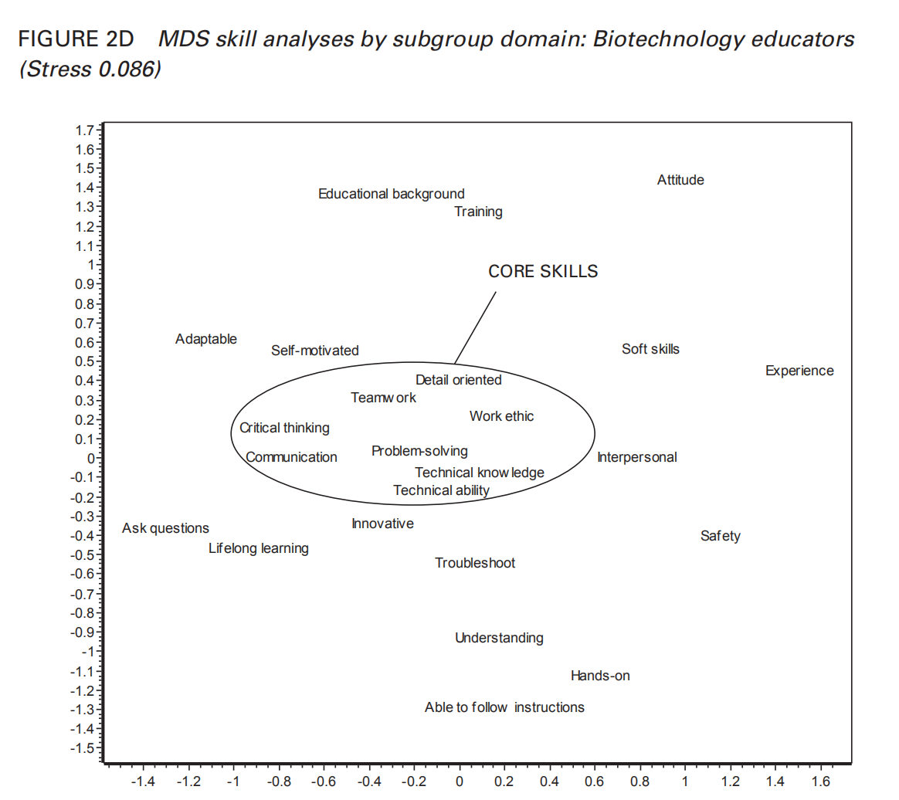

A few important skill terms are consistently linked across varying subgroups. This was particularly the case with teamwork and communication, which were explicitly linked by twenty-two respondents. Manufacturing and biotechnology educators and manufacturing employers believed that working well with coworkers depended on effective communication. Two different manufacturing employers, for example, emphasized how cross-functional teams were becoming more common in the engineering workplace, such that engineers had to communicate effectively with personnel from sales, production, and business administration. The value of communication skills in these workplaces was inextricably linked to specific work contexts, suggesting that communication across disciplinary and professional boundaries is especially important. Affiliation graphs for manufacturing employers and biotechnology educators, in particular, display the strong connections participants made between these two skills.

Contrasts do emerge among the connection data, however, that underline how varying contexts can lead to different perceptions of important skills. For instance, six educators explicitly linked critical thinking and problem-solving, while only one employer did the same. In a representative example, a biology instructor described teaching students how to objectively observe a process, recognize regularities within it, and use what one knew of these regularities to solve new problems: “What we want them to be able to do is, when they encounter something they’ve never seen before, kind of fall back on those fundamentals and kind of figure it out. There are consistent patterns, and if they can recognize those patterns and put together a model and figure it out, then they’re fine.” Similarly, while no educators explicitly connected adaptability and teamwork, six employers tied the skills together. Among these employers, this combination was often linked to the number of employees in their firms. “We are a small company. We only have thirty employees,” one manufacturing employer told us. “So learning to adjust to who you’re working with at any given time is a necessity.” These data indicate, again, that developing a better understanding of contextual factors (e.g., discipline, workplace tasks, company size) can give us a unique perspective on how respondents conceptualize competencies.

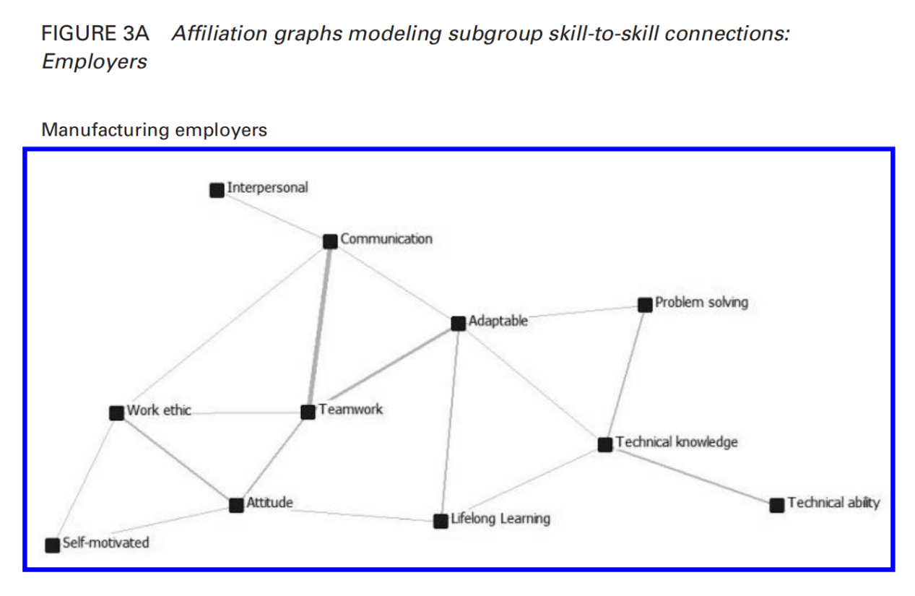

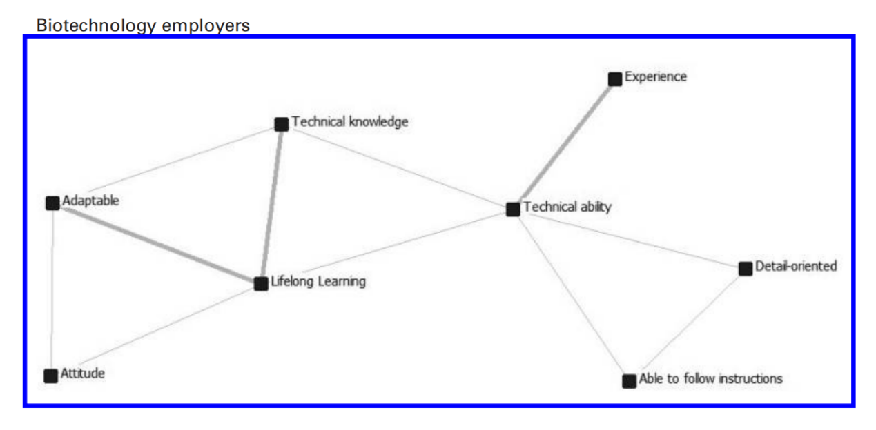

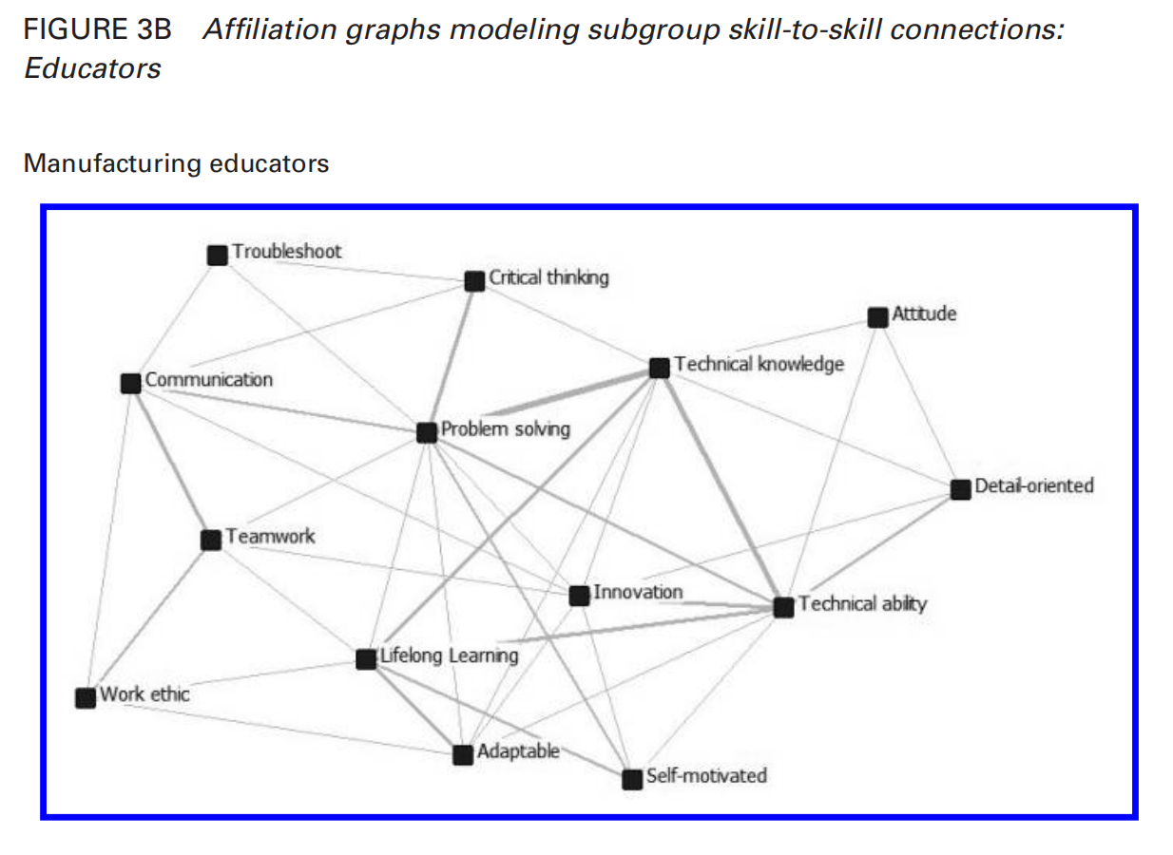

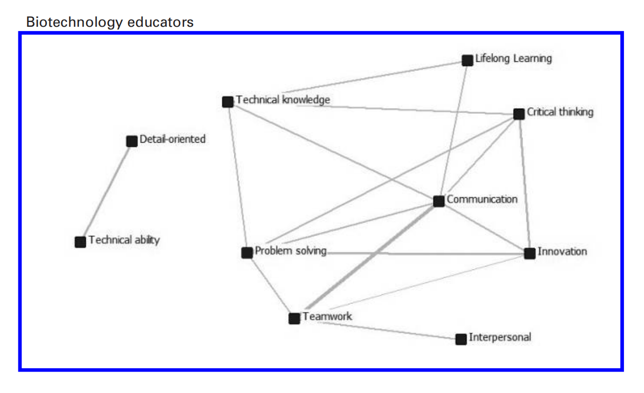

*Question 3: What contextual factors impact how educators and employers conceptualize, structure, and use valued skills?*

Finally, instead of embracing the implicit contention in the employability narrative that skills are uniformly defined and independent of context, we examined data to explore how educators and employers, operating in unique settings, may differentially conceptualize or assign value to certain skills. Results show a number of situational factors influencing how respondents defined and deployed skills-related cultural models, including personal background, generational status, organizational culture, public governance, geography, and occupational categories. While space limitations do not allow us to examine all these contexts in detail, we offer a brief synopsis, based on inductive thematic analysis of interview data, of how educators and employers described two prominent culturally oriented themes from the data: organizational culture and geography.

— Organizational Culture

Many employers in the study spoke of the importance of job applicants matching an organization’s “culture,” which they reported as a major influence on which skills were valued and prioritized during the hiring process. While varying definitions were offered, which is consistent with the variety of interpretations of the construct in the literature (Martin, 2002), organizational culture was generally viewed as a combination of the norms and practices that exist within particular departments. One employer spoke about the “strong personalities” of staff within the department where there was a job opening, saying that this aspect of organizational culture affected her approach to hiring because she would need to find applicants who “fit” this unique culture. Another employer called the last phase of employment vetting the “cultural phase” and told us that his hiring team consistently asked if applicants would “interact well with the people that they’ll be asked to interact with.” In particular, hiring managers told us they sought to match specific applicant dispositions (e.g., tastes, personality traits) and various interpersonal and intrapersonal skills to their organization’s culture. Similarly, one biology instructor described this trend by noting how newer biotechnology firms look for employees willing to work longer hours: “You work at a startup company and ... you wanna work very hard in order to make something work. That could be totally different if you’re going into a bachelor’s-level position at [a more established company] in Madison where it could be just a real nine-to-five job.”

The traits that were most frequently reported as playing a key role in estimations of cultural fit included personality (e.g., a “good” or “respectful” personality matching existing staff), communication and teamwork, and a strong work ethic. While technical knowledge and ability were generally highly valued, a candidate’s educational credentials and technical background took a backseat to estimations of cultural fit for positions in which a person could be trained to perform a routinized task or use a particular machine. Thus, the unique customs, workplace tasks, and personalities of existing staff largely dictated which attributes and competencies employers valued during the hiring process. This finding confirms prior research on the subjective aspects of hiring, where cultural capital acts as a strategic resource that can shape a person’s acquisition, or not, of position and prestige and employment discrimination based on race (e.g., Moss & Tilly, 1996), class (e.g., Rivera & Tilcsik, 2016), and gender (e.g., Gorman, 2005) can be justified simply as “cultural matching” (Rivera, 2012). Indeed, the tendency of some manufacturing employers in our study to use masculine third-person pronouns and possessive determiners (he, him, his) to describe typical employee attitudes, skills, and behaviors suggests that women may continue to be disadvantaged in this regard, especially in male-dominated fields.

— Geographic Location

Educators and employers also reported that geographic location was an important factor influencing their views on workplace competencies. According to respondents, various regions of the state were strongly associated with distinct skills and attributes. Work ethic, for instance, was associated not only with rural areas of the state but also with manufacturing centers in northeast Wisconsin’s Fox Valley and Milwaukee. Others pinned a strong work ethic to Wisconsin people more generally. “I think a lot of the history of people who’ve lived in Wisconsin have tended to have good work habits, whatever those are,” one engineering professor explained.

Such regional and state contrasts in valued (and prevalent) competencies support research showing the ways conceptions of skill can vary according to geographic space (e.g., Holt, 2008), as well as how space may bestow prestige on certain individuals over others. Taking our cue from cultural geographers and ecological economists who have shown how complex social, economic, and environmental realities are often intertwined (e.g., Berkes & Folke, 2000), we conceptualize how the values and norms in one social or cultural context — based in a geographic location like northeastern Wisconsin, for instance, where manufacturing companies have supported a good proportion of the local populace for generations (Wisconsin Cartographers’ Guild, 1998) — may bestow prestige on individuals who possess certain manufacturing-related skills. This status, however, is not conferred on those same skills in other geographical contexts, like Madison, where highly technical administrative and scientific competencies are more highly valued because the state’s government and flagship university have been centered in the city since the nineteenth century (Current, 2001; Wisconsin Cartographers’ Guild, 1998).

Some employers and educators also told us that the nature of local industry — whether it was biotechnology in Madison or metal manufacturing in the southeastern part of state — was an important determinant of both skill privation (whether local workers did not have certain competencies) and skill profusion (whether local workers had certain competencies). In regard to skill profusion, one manufacturing human resources director in eastern Wisconsin told us, “We’ve been a region ... because of that core metal manufacturing, machining, metal fabrication skill set, [where] work has come here from companies that require those ... skills.” Other participants indicated that the perceived shallowness of the local worker pool forced them to bring on people lacking technical competencies (but with the capacity to learn quickly) or to hire from other parts of the state. According to educators, these kinds of local industry needs directly shaped curriculum and instruction via company advisory boards and student demand in technical colleges, in particular. Cultural models for workplace skills can thus be viewed as strongly tied to place.

**Conclusions and Implications**

Our goal in this article is to problematize the employability discourse, along with those ubiquitous lists of valuable workplace skills college students should acquire, using a culturally oriented analysis of the way insiders actually think about and use these skills in real-world settings. While the employability narrative conceives of higher education as a venue in which discrete, generic attributes should be instilled for employment purposes, our data raise questions about this worldview and the widespread notion that getting a job is simply a matter of a student possessing the “right” skills. While we advance no claims of generalizability beyond our sample, we highlight implications of the study for research, policy, and practice moving forward.

*Reconceptualizing Skills as Multifaceted and Situated Cultural Models*

Our evidence demonstrates that workplace competencies are more nuanced, value based, contextual, and cultural than the employability skills discourse acknowledges. Indeed, the postsecondary and workforce stakeholders with whom we spoke discussed “skills” in ways that offer two objections to this narrative: first, that they are not stand-alone bits of individualized aptitude but instead are interconnected assemblages of skill, knowledge, and ability; and second, that they cannot be adequately understood if divorced from specific geographic, professional, and cultural contexts.

Cultural models offer a productive way to speak about skills that are attentive to these findings, as cognitive and embodied theories of relationships among people, ideas, and events that are developed through the repeated activation of unique neural networks in relation to specific situations (Strauss & Quinn, 1997). Such models do not necessarily dictate behavior but do act to “frame experience, supplying interpretations of that experience and inferences about it, and goals for action” (Quinn & Holland, 1987, p. 6). When combined with internalized declarative (knowing *what*) and procedural knowledge (knowing *how*) — two elements commonly associated with the idea of “skill” (Merriam-Webster, 2018) — cultural models can translate into habituated action as a form of practical reason (Strauss & Quinn, 1997). Instead of acting as fixed rules or scripts for behavior, however, cultural models and the cognitive schemata that comprise them can take on different configurations or causal forms depending on the situation, or trigger, that leads to their activation. In this way, viewing skills as multifaceted, interconnected, and situated cultural models links an individual’s knowledge and abilities inextricably with their historic and contemporary social *and* cultural environments.

Work ethic, a competency rooted in cultural, social, and dispositional factors, is a prime example of this complexity. Though there were subtle differences in how work ethic was described among biotechnology or manufacturing educators and employers, the term has a special cachet among many of the Wisconsinites we spoke to, one that stems from the state’s blue-collar, agricultural traditions that defy easy categorization. Indeed, some have argued that work ethic may not even be a fixed attribute at all but instead a multidimensional trait that evolves over time and changes with the individual and situation (Wentworth & Chell, 1997). Technical ability, lifelong learning, communication, and teamwork, we believe, are similarly complex cultural models as unworthy of the mechanical label “skills” as they are deserving of careful, nuanced, and contextualized analysis.

With this in mind, it is important to recognize that conceptions of whether one possesses or does not possess certain competencies are tied very closely to occupational and disciplinary communities. In such spheres, which are not dissimilar from communities of practice (Lave & Wenger, 1991) or occupational communities (Van Maanen & Barley, 1984), particular cultural models for and about work are honed through repeated practice and passed down through the generations. Furthermore, these communities define the criterion for entrance into the profession, such that cultural models can act as a form of internalized and embodied cultural capital that allow one to “purchase” position and prestige (Lizardo, 2004). While the employability skills discourse has usually portrayed the judgment of skills, knowledge, and ability in acultural, technocratic terms, our study suggests that such assessment would be more accurately defined by a fundamental arbitrariness equating subjective judgment with common sense (Bourdieu & Passeron, 1977). By deconstructing and evaluating competencies in this way, the employability discourse advances a narrative devoid of human context or cultural meaning.

*Power, Equity, and Neoliberalism in Postsecondary and Workforce Fields*

Of course, the role that much wider historical, political, and economic realities play in the daily conception of valued competencies figures prominently in the employability narrative. Postsecondary policy reforms around “skills” can partly be understood as the result of market-driven movements and discourses that have been influential in the United States since the late 1970s (Grubb & Lazerson, 2009; Harvey, 2005). By means financial and rhetorical, these market-centered norms have led to growing pressure on public colleges and universities to align their values and practices more closely with the needs of the business community, which, Urciuoli (2008) argues, most stands to benefit from “socially embedded [skills] discourses in which workers become ... entrepreneurial agents responsible for company success” (p. 213). According to this logic, individual, contextualized, and culturally determined traits and dispositions are reconceived as commodified, testable units, objective “‘things’ that can be acquired and measured and possess an inherent capacity to bring about desired outcomes ... that can be measured in dollars” (Urciuoli, 2008, p. 212). The implication of this discourse for higher education is straightforward. While educator and employer participants in this study told us it took practice, support, and time to truly develop the valued and complex skills discussed above, the discrete, testable skills imagined in recent market-oriented discourses seem more amenable to the shorter-term, and cheaper, kinds of training programs supported by many policy makers and businesses (Hora et al., 2016).

With this in mind, we believe practitioners, scholars, and administrators in colleges and universities should be skeptical of the notion of employment offered by the employability discourse and attendant skills frameworks and, more generally, of the role that higher education can play in helping students succeed in the job market. Indeed, considering that other research in multicultural and transnational contexts shows that conceptions and expressions of important skills vary between historical, social, and cultural settings (FantaVagenshtein, 2013; Golden, 2015; Hecht & Shin, 2015; Kirchgasler, 2018), and that even well-tested modes of skill assessment are context-specific (e.g., Earley & Ang, 2003; Greenfield, 1997), this skepticism should extend to increasingly common skill measurement methods used for postsecondary enrollment, employment, the military, and school placement (Kyllonen, 2013; also see Duckworth, 2016). Further field research on occupation- and discipline-specific views of valuable skills, as well as the perceived mutability of personality traits, will be vital in this regard, as will discussions about how to better provide students with the kind of social and cultural capital they need not only to lead satisfying careers but also to make a difference in the lives of others. Particular attention must also be paid to evidence-based forms of curriculum and instruction — especially through active learning that cultivates informed inquiry, creativity, and transfer — that can enhance students’ learned acumen as well as their ability to continue learning and growing as they move between and among any number of social and cultural spaces through their lives (e.g., Brown et al., 1989). Culture and context, simply put, should be our focus.

This reminds us of the stakes involved. One of the core ideas animating Bourdieu’s work on education is that schooling is a prominent venue for the reproduction of cultural, social, and economic inequality (Bourdieu & Passeron, 1977). Those who control the curriculum and thus the valued forms of cultural capital in a course of study, he noted, effectively manage the “logic of its transmission” to the next generation, usually in ways that favor those with power (Bourdieu, 1986, p. 249). In thinking about how different competencies are internalized by students via formal schooling and then transferred into employment fields, we believe it is useful — and deeply democratic — to think of skills such as work ethic, communication, and lifelong learning not as unassailable measures of an individual’s capability or merit, but as habituated cultural models necessarily defined and valued by particular groups at particular times for particular reasons. In so doing, we begin to utilize a language for talking about processes of student socialization and education that emphasizes not only the role that culture plays in shaping success, but also the essential capriciousness of the employability skills narrative. Considering the narrative’s profound influence on education policy as well as how we look at the goals of higher education, this, in and of itself, is a meaningful feat.

**ACTIVITY 3**

*Qualitative researches sometimes lead to quantitative researches, in that qualitative research can help in:*

* developing a hypothesis about the relationship between certain attitudes, values, and behaviors, which can be tested later by using quantitative research;
* doing a pilot or exploratory study to determine the major issues, attitudes, values, perceptions, and viewpoints to examine further in a quantitative study;
* indicating the relevant categories or subjects to include in a larger study, as well as the questions to ask;
* determining the right words and phrases to use in asking questions of members of a particular group or culture.

*Read the papers in READING 2 again to understand how a qualitative research can provide a basis for a quantitative study.*

**ACTIVITY 4**

*While we appreciate the value of the qualitative approach, it is also necessary to understand its main disadvantages. Consider the following cases and provide reasons where necessary.*

* It can’t be used to test hypotheses, because __in most qualitative research, you instead of prove or disprove some hypotheses, you try to explore or examine the reason_____
* It can’t be subjected to the kind of reliability and validity testing done in quantitative research, such as when subjects are randomly selected for the study or when an experimental design with control and experimental groups is used.
* The results can’t be generalized to a larger group, since ___qualitative research is intended to explore a small number of cases in depth and not to generalize to a larger group._________________________
* When a researcher studies a small group, such as through participant observation, the researcher’s presence might influence the behavior and attitudes of group members.

**补充阅读**

（选自《研究生通用学术英语教程》）

*The article that follows is taken from the “Introduction” to the chapter of “Methods for Researching the Second Language Classroom” in “Language Teaching Research and Language Pedagogy” by Rod Ellis. It introduces different forms of second language classroom research.*

**Formal L2 Classroom Research & Practitioner Research**

It is useful to make a broad distinction between formal and practitioner research. By formal research I mean research that is conducted by an external researcher drawing on one or more of the established research traditions. Formal classroom research can be motivated by theoretical issues (e.g. whether opportunities to negotiate for meaning facilitate second language — L2 — learning) or by pedagogic issues (e.g. how and to what extent teachers implement a particular approach to language teaching). In many cases, the issues investigated are of both theoretical and pedagogical significance. Practitioner research is research conducted by teachers in their own classrooms drawing on the principles of action research (for example, Wallace, 1998; Burns, 2009) or exploratory practice (Allwright, 2003). It is invariably motivated by pedagogic concerns and is directed at enabling teachers to solve problems they are experiencing with their teaching or develop a deeper understanding of some aspect of the quality of life in the L2 classroom. It should be noted, however, that both types of research have in common the general features of research — that is, there is a problem or question to be addressed, data is collected and analyzed and an interpretation of the findings provided.

**Formal L2 Classroom Research**

It is helpful to begin with some examples of formal classroom research. I will draw on a series of classroom-based studies that my fellow researchers and I conducted in the 1990s, all of which were informed by Long’s (1983) Interaction Hypothesis. This hypothesis claims that L2 acquisition is facilitated when a communication problem arises that causes learners to try to resolve it through the negotiation of meaning. Negotiation potentially aids acquisition in a number of ways — by helping to make input comprehensible, by prompting learners to notice the difference between their own erroneous output and the correct target language form through feedback, and by pushing learners to self-correct. Numerous studies have investigated the Interaction Hypothesis. However, many of these were laboratory studies. My own studies, which sought to investigate the effect that negotiation had on comprehension and the acquisition of vocabulary, all took place in a classroom context. The studies were all experimental in nature. That is, there were one or more experimental groups that received a “treatment” (consisting of either input that had been premodified to facilitate comprehension or input that the students had the opportunity to modify through interaction or an opportunity to use the target items in production). In all the studies there was a pre-test to establish which of the target vocabulary the students already knew, a post-test more or less immediately following the treatment, and a delayed post-test to establish whether any learning that had taken place was durable. The formal nature of my research is evident in a number of ways. First, as already stated, it was theoretically motivated. I wanted to test the claims of the Interaction Hypothesis. At the time, although a number of studies had shown that modified interaction assisted comprehension, there were few studies that had investigated whether it facilitated acquisition. Thus, there was a conspicuous “gap” between what the Interaction Hypothesis claimed and the supporting evidence. My intention was to try to ﬁll that gap. Second, I wanted to demonstrate a cause-effect relationship (i.e. the relationship between interactionally modified input and output and L2 acquisition). For this reason, I elected to use an experimental design rather than carry out a purely descriptive study. Third, as a university professor I was keen to conduct a study that would lead to publications in academic journals. The articles that resulted from the research were published in *Language Learning*, *Applied Linguistics* and *Studies in Second Language Acquisition*, all leading journals in my field. Nevertheless, even though my research was clearly theoretical in nature, it was also of potential practical significance. If it could be shown that learners could successfully learn vocabulary by performing listen-and-do tasks then I would be in a position to propose that such tasks had a place in language pedagogy. Indeed, I chose to investigate the Interaction Hypothesis precisely because of its pedagogic relevance.

Not all formal research is driven by theory. Much of the L2 classroom research has been descriptive in nature, aimed at understanding a specific aspect of teaching or learning and also at providing information that can ultimately be used to shape a theory. A good example of such research is Lyster and Ranta’s (1997) study of how teachers in French immersion classrooms correct students’ linguistic errors when interacting with them. Such studies can also be considered formal in that they are carried out by researchers (Lyster and Ranta are both university professors) rather than by teachers and were conducted with a view to publishing an article in an academic journal (Lyster and Ranta’s study was published in *Studies in Second Language Acquisition*). Also, like my experimental studies, this study was intended to contribute to theory. Indeed, Lyster followed up this descriptive research with a number of experimental studies (see Lyster, 2004; Lyster and Mori, 2006) which were informed by the findings of the earlier descriptive study and which sought to investigate theoretically based hypotheses about the relative effectiveness of different types of corrective feedback. Finally, also like my studies, Lyster and Ranta’s study aimed to contribute to language pedagogy. Formal L2 classroom research, then, whether experimental or descriptive, aims to contribute to research-based language pedagogy. That is, it seeks to provide teachers with information that they can use to decide what and how to teach. Its characteristics are as follows:

1. The phenomenon investigated is determined by the researcher.
2. The researcher “borrows” a classroom in order to carry out the study.
3. The researcher may also solicit the help of a classroom teacher to conduct the research.
4. The research is either theoretically driven (as in experimental research) or carried out with a view to developing theory (as in descriptive research).
5. The results of the research are written up in accordance with the requirements of academic articles and with a view to publishing them in academic journals.
6. In many cases the research is intended to contribute to research-based language pedagogy.

Such research is of undoubted value — both for testing and developing theory and for language pedagogy. A limitation, however, is that it may not address the kinds of issues that preoccupy teachers and, in fact, may never reach teachers as they are unlikely to read the journals in which it is published. Thus, if it does have an impact on teachers it will do so in a top-down fashion — that is, through the mediation of teacher educators who draw implications for teaching from the research and convey these to teachers. In the view of some researchers and teacher educators, teachers would do better to engage in their own practitioner research.

**Practitioner Research**

Practitioner research is research conducted by practitioners (usually teachers) in their own classrooms either acting independently or in collaboration with others. Stewart (2006), citing Thesen and Kuzel (1999: 27) notes that it is “oriented towards reform rather than simply toward description or meaning”. Practitioner research, then, is directed at enabling teachers to become “expert knowers about their own students and classrooms” (Cochran-Smith and Lytle, 1999: 16). In this way it aims to make a direct connection between research and practice. To this end, the research topics are not derived from theory but from teachers’ desire to experiment with some innovation in their classroom, to seek a solution to some problem they have identified with their teaching or their students, or simply to develop a fuller understanding of some aspect of life in their classrooms. Practitioner research, then, is inherently local. It is focused on a specific group of learners in a specific classroom where the teacher teaches. It follows that it should be evaluated not in terms of whether it contributes to our general understanding of some issue of theoretical significance but in terms of the contribution it can make to teachers’ practice of teaching and, through the reflection that it can promote, to teacher development.

Arguably, then, the value of practitioner research lies more in the process of conducting it than in the product of the research. Indeed, it can be questioned whether teachers engaging in practitioner research need to produce a product — in the form of a report or a public presentation of their research. However, Freeman (1996: 105) has argued that “the knowledge that teachers articulate through the process of disciplined enquiry must become public”. Borg (2009) too has emphasized the importance of teachers “making their research public” while acknowledging that teachers themselves express uncertainty about the need for this. There are obvious advantages in teachers sharing the results of their research — both for themselves (in terms of the feedback they will receive in a public forum) and for other teachers (who can benefit from the insights the research provides). There are a number of outlets available for the publication of practitioner research — teacher conferences and a number of journals (e.g. *Language Teaching Research* has a section entitled “Practitioner Research”). Practitioner research, however, is not likely to be published in the same academic journals as formal research, which raises the question of its status in the field of L2 classroom research as a whole.

A key point that emerges in discussions of practitioner research conducted by practitioners is the need for a model for how to conduct it. Such models have originated from teacher educators who promote teacher research as a way of both helping to solve local problems they are experiencing and of developing themselves as members of the teaching profession. I will consider two of the most widely promoted models — action research and exploratory practice.

**Action research**

Action research is “a form of self-reflective enquiry undertaken by participants in social situations to improve the rationality and justice of their own practices, and the situations in which those practices are carried out” (Carr and Kemmis, 1986: 162). As so defined, it applies to a wide range of professional activities. Indeed, its origin lies in the work of Kurt Lewin (1948), who conducted research that showed that the highest level of output by factory apprentices was by those who had the opportunity to formulate their own “action plan”. Action research is intended to lead to improvement in the practice of some professional activity — in our case, in language teaching. It can be undertaken by individual teachers or collaboratively involving a team of teachers. Readers interested in the historical development of action research in the field of language teaching should refer to Burns (2005).

The model for conducting action research for teachers emphasizes a number of features: (1) it is context-specific, (2) it is practical, (3) it is systematic, (4) it is reflective, and (5) it is cyclical. The model proposes a number of iterative phases:

1. Identifying an issue or problem relevant to a specific instructional context (the initial idea).
2. Obtaining information relevant to the problem/issue (fact finding).
3. Working out a possible solution to this problem and devising ways of trying this out (the action plan).
4. Trying out the solution in the specific instructional context (implementation).
5. Collecting data to investigate whether the solution is effective (monitoring).
6. If necessary, revising the action plan and proceeding through steps (4) and (5) again or alternatively identifying a new issue thrown up by the initial study.

Such a procedure is context-specific in that the problems are identified by teachers and are located in their own teaching. It is practical in that it is directed at improving teaching. It is systematic in that it offers a set of clearly delineated steps for conducting an action research study. These steps, it should be noted involve more than just teaching (i.e. they involve the collection and analysis of data). It is reflective in that it requires teachers to examine problems in their own teaching, identify possible solutions and evaluate their effectiveness. It is cyclical in that it recognizes the importance of continuous research to find solutions and the possibility of new problems arising out of teachers’ attempts to find solutions to initial problems.

Here is a small-scale action research study conducted by a teacher in her own classroom to address the problem of her students’ use of the first language (L1) — Japanese (Penner, 1998). This is a problem that arises in many monolingual language classrooms. Penner’s study is not a classic action research study but has clear elements of action research. That is she identified a general problem and then narrowed this down to more specific problems she was having with the students’ using their L1. She tried out solutions to these specific problems but did not systematically investigate their effectiveness. This ultimately led her to collect data to help develop a better understanding of the problem. The questionnaire she administered helped her to see more clearly why her students used Japanese. In particular, she came to understand that it was motivated by the social need to establish a relationship/rapport with their fellow classmates. In this study, therefore, the action research did not result in a clear solution regarding the use of the L1 but did stimulate reflection about the problem and a fuller understanding of its causes. At the end of it, Penner was better placed to work out new strategies for dealing with it.

Penner’s study serves as a good example of the importance of the first step in an action research study — specifying the problem or issue to be investigated. Indeed, undertaking this can constitute a study in its own right. Wallace points out that problem areas can cover a number of possibilities:

Problems with classroom management

Problems of appropriate materials

Problems related to particular teaching areas (e.g. reading, oral skills)

Problems relating to student behaviour, achievement or motivation

Problems relating to personal management issues (e.g. time management and relationships with colleagues / higher management) (1998: 19).

But he then notes that “the topics given are probably too broad” and recommends that teachers be more specific. Barkhuizen (2009) investigated the problems identified by a group of Chinese teachers of English working in universities. He asked them to complete the following sentence: “I remember once in my classroom I had a very difficult time trying to ...”.

His analysis of their responses found that the three most commonly identified problem areas were (1) students’ unwillingness to speak in class (reported by 29 per cent of the sample), (2) students’ lack of motivation (19 per cent), and (3) teaching materials (18 per cent). Barkhuizen also considered the reasons that these teachers gave for their problems. For example, reasons given for (1) included the students’ lack of proficiency, their insufficient knowledge about a topic, shyness, fear of being laughed at by others, lacking confidence, and focus on examinations. Clearly, it is not sufficient to simply identify a problem; it is also important to consider the reasons for why the problem exists, as only then is it possible to formulate a research question that can guide the study.

The precise specification of a problem is not something that teachers always find easy. Nunan (1990b) reported that teachers’ proposals tended to be rather grand and unmanageable because they had failed to identify specific research questions. It was with this in mind that I have proposed a different starting point for action research. In Ellis (1998) I outlined a procedure for conducting the micro-evaluation of classroom activities. The starting point for such research is not a problem but rather some “task” that the teacher is interested in using with the students. The idea behind my proposal is that teachers would benefit exploring empirically whether the task “worked” and that this would stimulate reflection on the choice of task and the manner in which it was implemented. I outlined a five step procedure for conducting a micro-evaluation: (1) description of the task, (2) planning the evaluation, (3) collecting information, (4) analyzing the information, and (5) reaching conclusions and making recommendations (e.g. For changes that were needed to the task materials or implementation). I distinguished three types of micro-evaluation: (1) student based (involving eliciting the views of the students about the task), (2) response-based (collecting data to see if the performance of the task accorded with its pedagogic aims), and (3) learning-based (investigating whether any language learning resulted from the performance). Many micro-evaluations involve more than one of these types.

However, action research — whether conducted in the traditional way or as a micro-evaluation of a task — is not without its problems. Barkhuizen’s teachers expressed a number of these — it is very time-consuming, they lacked the expertise to conduct research and their students might not be willing to participate. Doubts have also been expressed about its lack of rigour and therefore its lack of status in academic circles. Brumfit and Mitchell (1990), for example, argued “there is no good argument for action research producing less care and rigour unless it is less concerned with clear understanding, which it is not” (p.9). While I think Brumfit and Mitchell have partly missed the point of action research (namely, that it constitutes a process that can stimulate reflection on teaching and, therefore, does not need to conform to academic criteria for research), it does raise the important question of what standards should be used to judge it. The key issue, however, concerns its feasibility. It was his belief that teachers could not be expected to engage in action research without “burnout” that led Allwright (2003) to propose an alternative form of practitioner research for teachers.

**Exploratory practice**

Allwright (2005) has argued strongly in favour of “exploratory-practice”. He explains that this developed out of two ethical concerns — “the damaging split between researchers and teachers and the high risk of burnout associated with current proposals for teacher-based classroom research” (p.27). Allwright (2003) formulated a number of general principles to guide the practice of exploratory research. At the centre of these is the notion of “classroom life”, which Allwright suggests should be considered in terms of the “quality of the learning”, the “quality of education” and, ﬁnally, the “quality of life” with the latter involving factors that lie outside the classroom itself. Allwright’s principles were:

1. Put the “quality of life” ﬁrst (i.e. “practical problems” are best considered in context and will involve a holistic understanding of the “lives” of the participants involved).
2. Work primarily to understand the language classroom life. Allwright emphasizes that “only a serious effort to understand life in a particular setting will enable you to decide if practical change is necessary, desirable and/or possible” (p.128). This requires converting a “practical problem” into a “puzzle”.
3. Involve everybody. Allwright sees exploratory research as a collaborative endeavour, involving learners as “co-researchers”.
4. Work to bring people together. The need for social harmony requires that exploratory research be directed at achieving collegiality.
5. Work also for mutual development. Participants in the research should work for each other’s development.
6. Integrate the work for understanding into classroom practice. Allwright argues that “practitioner research must not become parasitic upon the life it is trying to understand” (p. 129). This implies that any investigative tool used should be part of the instructional activities that are a natural part of a lesson.
7. Make the work a continuous enterprise. Exploratory research needs to be seen as “a continuous, indeﬁnitely sustainable enterprise” (p. 130). A corollary of this is that teachers should avoid time-limited funding as this will compromise the whole enterprise.

Exploratory practice, then, aims to make the time that teachers and learners spend together “pleasant and productive” and, in so doing, create the conditions for pedagogic change. For Allwright, teacher research needs to be feasible: he argues that if teachers see classroom research as too demanding, they will not engage in it. It is for this reason that exploratory practice needs to integrate enquiry into classroom practice. He sees the role of academic researchers as “consultants” rather than “directors”; they should advise on the conduct of investigations but not attempt to control them. Above, all exploratory research needs to be a collegial enterprise; the investigations should involve learners as well as teachers and should focus on “puzzles” rather than on “problems”.

Bloom’s (2007) study of the tensions that arose in a Spanish course for university level health professionals reflects the seven principles of exploratory research. She was primarily concerned with the “quality of life” of her classroom, this being the driving force behind her wish to understand why tensions arose and to find ways of addressing them. Bloom treated these tensions as a “puzzle” rather than as problems. She involved the students and herself in exploring the tensions and ways of relieving them. She was constantly concerned with “bringing people together”, recognizing that the tensions arose because of differences between her own and the students’ expectations (e.g. Some of her students were focused on achieving accurate products in Spanish where she was more concerned with engaging them in a communicative process). She constantly worked for mutual development — both the students’ development as effective learners and her development as a teacher. She was very careful to integrate her investigative tools into the practice of her own teaching: the students were not asked to perform any tasks purely for the purpose of data collection. Her work was truly a continuous enterprise, covering the duration of the semester-long course. Commenting on Bloom’s article, Allwright (2007) emphasizes that what lay at the centre of her study was the search for the “human issues” that arose in her classroom and the importance of “dialogue” as a means of understanding and resolving these issues.

There are a number of differences between action research and exploratory research. One is the starting point — a “problem” or, perhaps, a “task” in the case of action research and a “puzzle” in the case of exploratory research. Another difference lies in the methodology for the two approaches. Action research employs similar methods of data collection to those found in formal research and involves going beyond the materials used for teaching; exploratory research embeds data collection into the actual practice of teaching. What they have in common is an emphasis on the continuous nature of the enquiry. Action research is “cyclical” (although to what extent this is actually achieved by many teachers is doubtful); exploratory research is a long-term enterprise and, because it is part of teaching is potentially more sustainable.

**Practitioner research: concluding comments**

Practitioner research is research carried out by teachers working in their own classrooms with a view to improving practice (in the case of action research) or understanding the “life of the classroom” (in the case of exploratory research). Where such research is published, it typically takes the form of narrative accounts. Both Penner’s action research study and Bloom’s exploratory research study were presented as “stories” about these two teachers’ experiences of how they investigated their classrooms and what they discovered through these investigations. They reﬂect Crookes’ (1993) call for new discourses and genres that can represent what teachers ﬁnd from their research. The question arises as to the contribution that such “stories” can make to our knowledge of how language learning takes place in a classroom. If such research is to be judged by the standard criteria of generalizability and replicability, it is doubtful that it will have much impact on the knowledge-base of L2 classroom research. However, if it is judged by alternative criteria — for example, “meaningfulness” and “trustworthiness” (Mishler, 1990), then, it can be seen as affording insights that can inform the knowledge base. It would seem foolish to ignore studies such as those of Penner and Bloom, as both address key issues (i.e.the use of the learner’s L1 and the implementation of learner-centred instruction) that are central to the study of the L2 classroom. Ultimately, however, the significance of such research lies not in whether it can or cannot contribute to our theoretical understanding of the L2 classroom but to its relevance to language pedagogy. As Allwright (2003: 131) noted “who stands to gain most ... will surely be the teacher and the learners (rather than ‘academic researchers’)”.

*Answer the following questions according to your understanding of the article above.*

1. According to the first paragraph of the article, what are the major differences between formal and practitioner research? And what do they have in common?

Formal research is conducted by an external researcher drawing on one or more of the established research traditions, while practitioner research is conducted by teachers in their own classrooms drawing on the principles of action research or exploratory practice. The common is that a problem or question to be addressed, data is collected and analyzed and an interpretation of the findings provided.

1. What are the major claims of Long’s (1983) Interaction Hypothesis?

This hypothesis claims that L2 acquisition is facilitated when a communication problem arises that causes learners to try to resolve it through the negotiation of meaning.

1. Why does the author say his own studies to investigate the effect that negotiation had on comprehension and the acquisition of vocabulary were all experimental in nature?

There were one or more experimental groups that received a“treatment”(consisting of either input that had been premodified to facilitate comprehension or input that the students had the opportunity to modify through interaction or an opportunity to use the target items in production).

1. Why could the author’s studies be regarded as formal and theoretical?

The formal nature of my research is evident in a number of ways. First, it was theoretically motivated. Second, I wanted to demonstrate a cause-effect relationship. Third, as a university professor I was keen to conduct a study that would lead to publications in academic journals.

1. How do you think can practitioner research make a direct connection between research and practice?

The research topics are not derived from theory but from teachers’ desire to experiment with some innovation in their classroom, to seek a solution to some problem they have identified with their teaching or their students, or simply to develop a fuller understanding of some aspect of life in their classrooms.

1. Why could the procedure of action research be regarded as context-specific, practical, systematic, reflective, and cyclical?

Such a procedure is context-specific in that the problems are identified by teachers and are located in their own teaching. It is practical in that it is directed at improving teaching. It is systematic in that it offers a set of clearly delineated steps for conducting an action research study. These steps, it should be noted involve more than just teaching (i.e. they involve the collection and analysis of data). It is reflective in that it requires teachers to examine problems in their own teaching, identify possible solutions and evaluate their effectiveness. It is cyclical in that it recognizes the importance of continuous research to find solutions and the possibility of new problems arising out of teachers’ attempts to find solutions to initial problems.

1. What are the three most commonly identified problem areas by Chinese university teachers of English in Barkhuizen’s research?

1、Students’ unwillingness to speak in class (reported by 29 per cent of the sample);

2、Students’ lack of motivation (19 per cent);

3、Teaching materials (18 per cent).

1. How does Bloom’s (2007) study of the tensions that arose in a Spanish course for university level health professionals reflect the seven principles of exploratory research?

1、She concerns with the “quality of life” of her classroom to understand why tensions arose and to find ways of addressing them.

2、She treats tensions as a “puzzle” rather than as problems.

3、She involves the students and herself in exploring the tensions and ways of relieving them.

4、She concerns with “bringing people together”.

5、She constantly works for mutual development — both the students’ development as effective learners and her development as a teacher.

6、She is very careful to integrate her investigative tools into the practice of her own teaching

7、Her work is truly a continuous enterprise, covering the duration of the semester-long course.

1. What are the major differences between action research and exploratory research? And what do they have in common?

1、differences: One is the starting point. In action research, it is a “task”. While in the case of exploratory research, it is a “puzzle”. Another one is the methodology for the two approaches. Action research employs similar methods of data collection to those found in formal research and involves going beyond the materials used for teaching; exploratory research embeds data collection into the actual practice of teaching.

2、common: All of them emphasize the continuous nature of the enquiry. Action research is “cyclical” (although to what extent this is actually achieved by many teachers is doubtful); exploratory research is a long-term enterprise and, because it is part of teaching is potentially more sustainable.

*Work in groups to discuss the following topics.*

1. How do you comment on the saying “the value of practitioner research lies more in the process of conducting it than in the product of the research”?

We find it necessary to clarify that the “product” here by author’s definition means formal and public accessible report and presentation. Teammates conflict on the saying. Some argue for its benefits, stressing the importance of accumulative experience sharable among every teacher and researcher in the field, while others who stand against the position rightfully point out that “a badly executed process almost never leads to a product of any real value”, therefore suggest that the teacher put much attention on the conducting. We thus believe that the value of process and product is hardly comparable when all factors in real life are put into consideration.

1. Do you agree “the (research) topics given (by Wallace) are probably too broad” and teachers should be more specific in their action research topics?

As we learn from the paper that carrying out a complete process of action research has been shown to drop way too much burden on the teacher’s part, we generally agree with Wallace’s advice of focusing on fewer but more manageable topics. But one of our careful team members notices the author mentioning “the point of action research” is not to “conform to academic criteria for research”, but to enhance teacher’s own understanding of pedagogy, or more casually speaking, for better achievements of every single person in this class. At the end we conclude that the scale of topic should be determined on a case-by-case basis, varying with the expectation of teachers and students in current teaching session.

1. Do you agree “reasons given for students’ unwillingness to speak in class included the students’ lack of proficiency, their insufficient knowledge about a topic, shyness, fear of being laughed at by others, lacking confidence, and focus on examinations”?

Team members’ opinions hilariously coincide on this question as our experiences seem to be the living proof of these reasons. We have also come up with other possible reasons like inability to catch up with teachers’ fast speech, low motivation due to summertime laziness, dizziness as the class is at 1pm, or even worser, resulting from last night's staying up, etc.